一、售电系统环境介绍 Vending system environment introduction 2

二、售电系统功能 Vending system functions 2

2.1售电系统登录 Vending system login 2

2.2公共档案管理 Public archive management 2

2.2.1 Tariff Project Management 3

2.2.2 STS Parameter Management 3

2.2.3 Prepaid operating personnel Archive 4

2.2.4 Operation Log Query 4

2.2.5 Import Meter Archive 4

2.3 Low Voltage Cost Control Archives 4

三、居民售电 Residential vending 6

3.1 居民售电业务 Residential vending business 6

3.2 售电 Vending 6

3.3 开户 Opening an account 8

3.4 销户 Closing an account 9

四、Inquiry 10

五、Reports 11

六、Tool 12

七、测试 Inspection 12

7.1 SetMaximumPowerLimit 12

7.2 ClearCredit 12

7.3 Set1ndSectionDecoderKey 13

7.4 Set2ndSectionDecoderKey 14

7.5 ClearTamperCondition 14

7.6 Set Maximum Phase Power Unbalance Limit 14

7.7 Reserved for Proprietary Use 15

7.8 缴费 Payment 15

7.9 class1测试 Class1 inspection 16

7.10 class2测试 Class2 inspection 16

7.11 其他测试 Other inspection 23

Question1:SM?TS balance 40

Question2:Credit Update Block 41

## 一、售电系统环境介绍 I. Vending system environment introduction

STS售电系统使用的测试网址如下：

<http://222.222.60.178:19998/sdweb/login.jsp>

端口为19998

STS vending system testing URL is as below:

<http://222.222.60.178:19998/sdweb/login.jsp>

Port: 19998

## 二、售电系统功能 II. Vending system function

### 2.1售电系统登录 2.1 Vending system login

打开网址后，登录界面如下图，用户名默认为sdadmin，密码为kesd123456

售电系统测试串口通过xml文件配置，此处为com3

After opening the URL, the login interface is as shown below.

Default user name: sdadmin

Default passport: kesd123456

Vending system testing port is configured through the xml file, here is com3

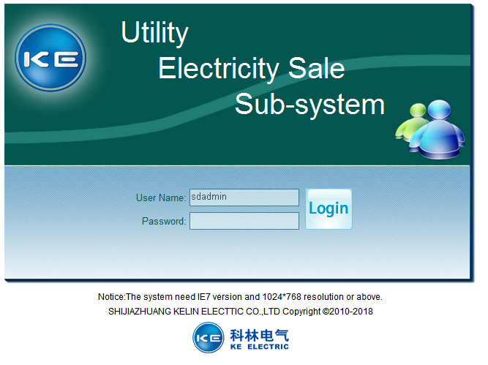

登录后的界面如下图

The interface after login is shown as blow.

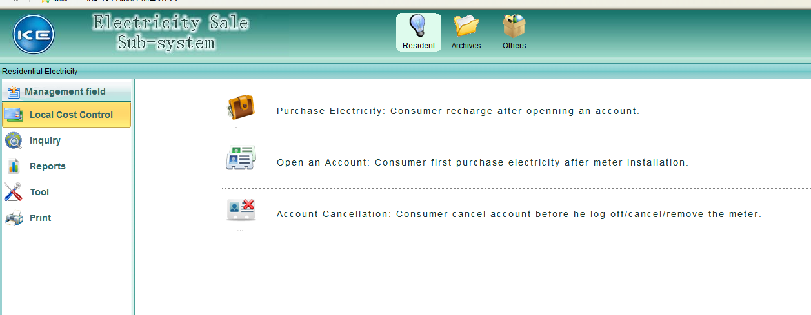

### 2.2公共档案管理 2.2 Public archive management

点击Archives，进入档案管理界面，左侧菜单分为Public Archives和Low Voltage Cost Control Archives。首先我们进入Public Archives，显示当前的公共档案内容

Click “Archives” to enter the archive management interface. There are two submenus in the menu on the left hand. Choose “Public Archives” to check the current public archive contents.

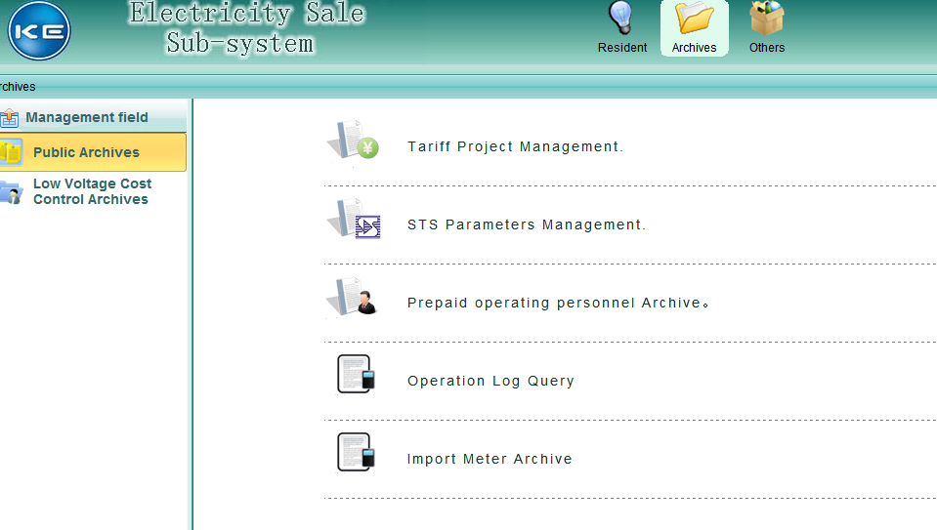

#### 2.2.1 Tariff Project Management

费率方案管理界面，根据当地电价，建立费率档案，Tariff Index一般默认为1，TariffType默认为单费率，透支限值与电表预置透支金额一致，Total Tariff为单价。

You can set up tariff archive according to local rate in Tariff Project Management page.

Default tariff index: 1

Default tariff type: Single rate

Default overdraft limit: same with the overdraft limitation set in the meters

Total tariff: unit price

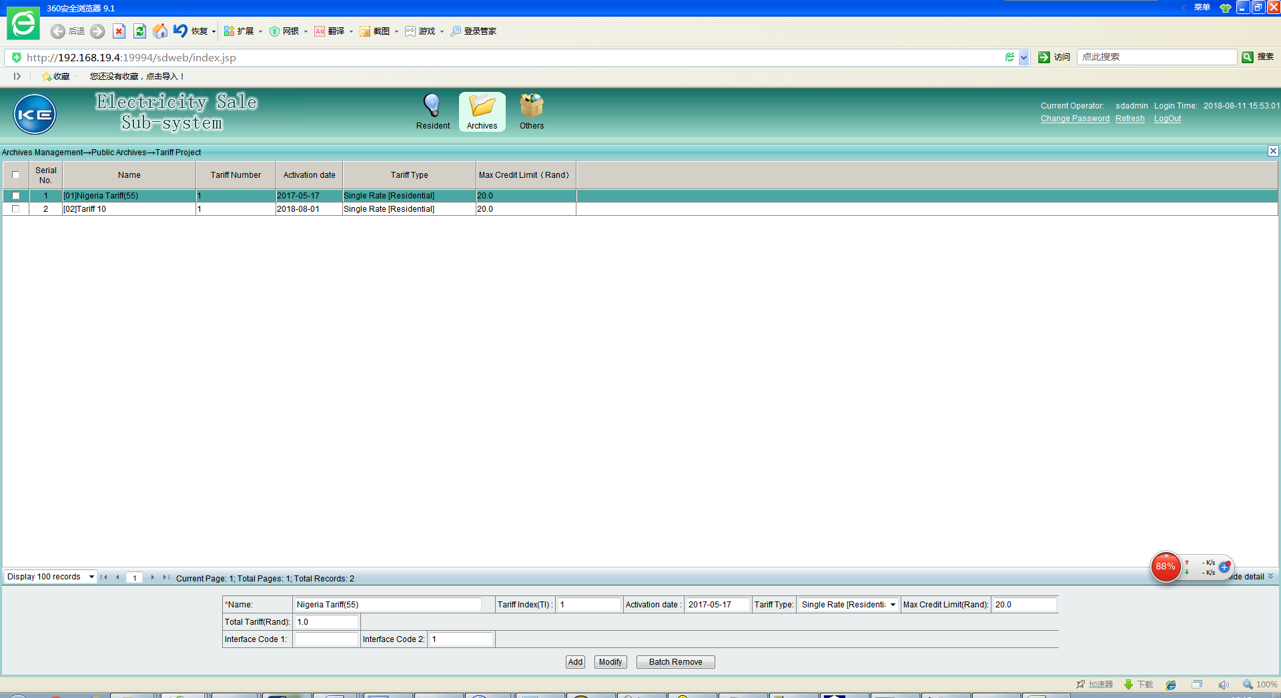

#### 2.2.2 STS Parameter Management

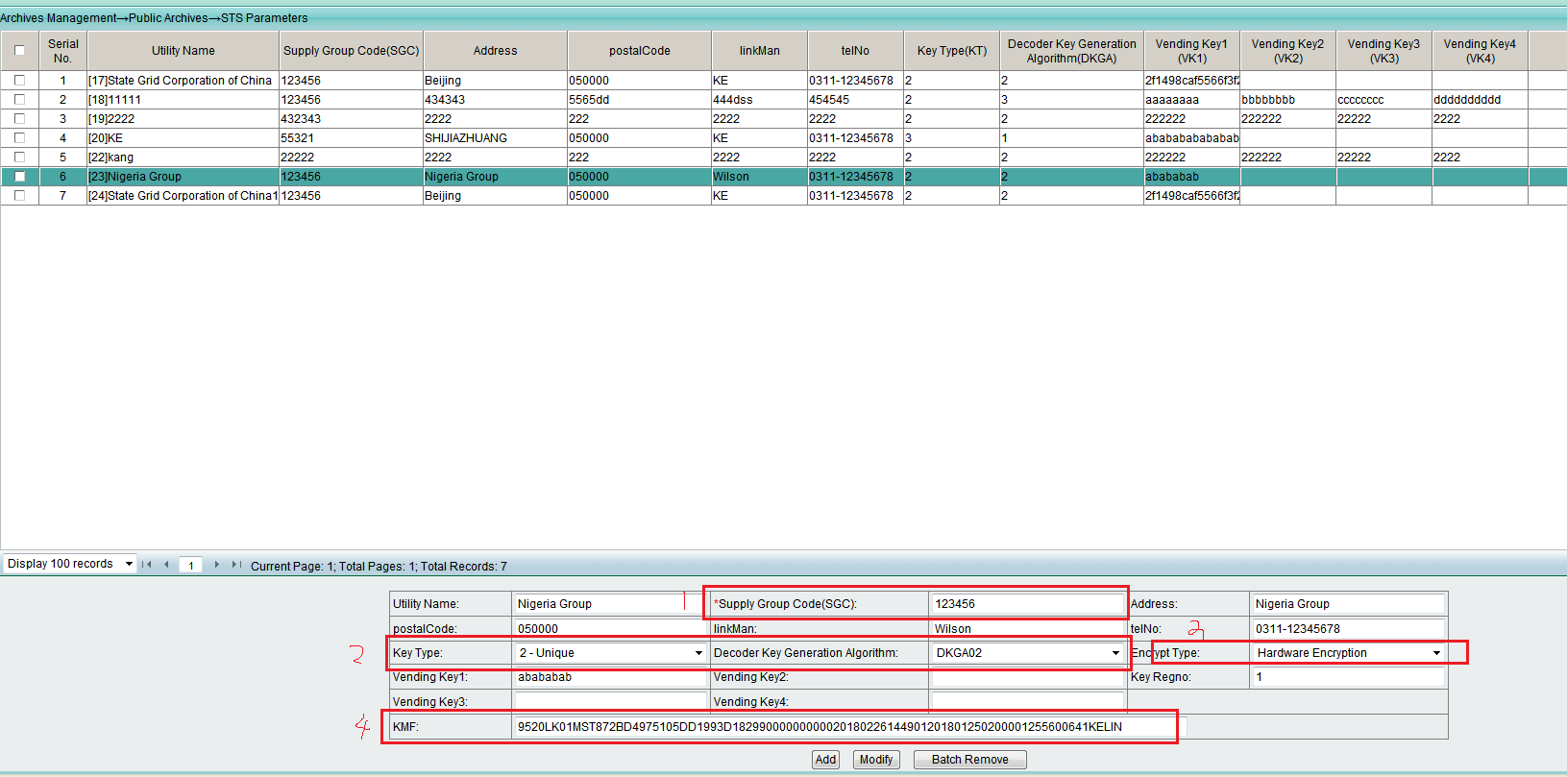

STS参数管理SGC相关信息，如SGC码，keyType，DKGA等，使用STS加密模块，请设置EncryptType为Hardware Encryption，同时设置KMF串。

STS parameter manages the SGC information such as SGC code, keyType and DKGA. Please set the EncryptType as Hardware Encryption and set the KMF serial number, too.

#### 2.2.3 Prepaid operating personnel Archive

建立售电操作员档案，配置操作员管理权限，如浏览权限，建档权限，修改权限，报表权限，缴费权限等。

Establish the vending operator archive and configure relative management permission such as browse/set up archive/modify/generate report/payment, etc.

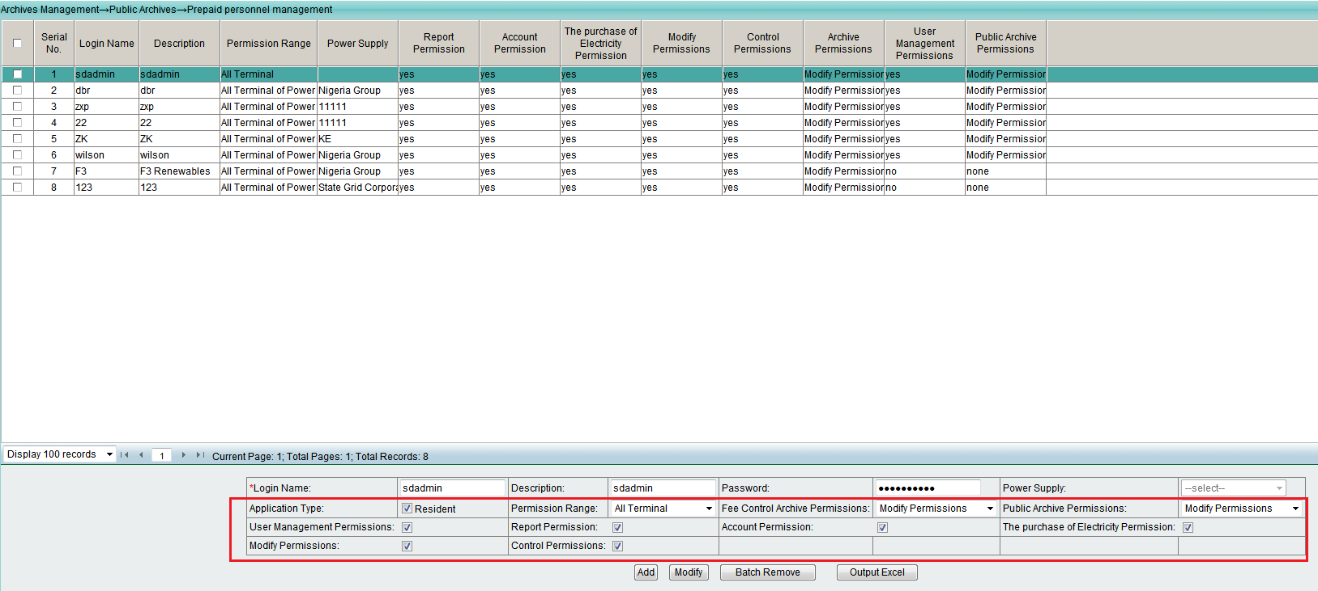

#### 2.2.4 Operation Log Query

操作日志查询

Operation log query.

#### 2.2.5 Import Meter Archive

批量导入电表档案，实现批量开户

Batch import meter archives for bulk account opening.

### 2.3 Low Voltage Cost Control Archives

建立STS居民区档案、采集终端档案、居民档案及电表档案。

Establish STS residential area archive/terminal archive/resident archive and meter archive.

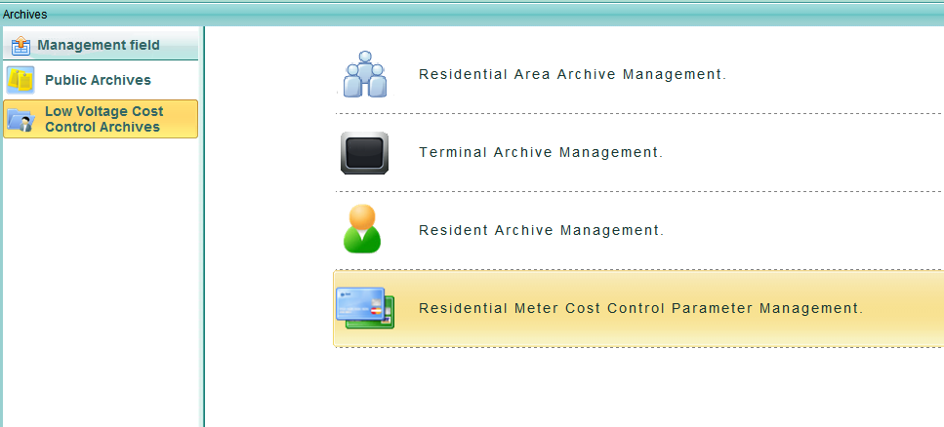

此处我们创建两块电表，电表地址为测试电表地址，第一块地址为0000000000，第二块为010000000000.

选择Residential Meter Cost Control Parameter Management,进入电表档案，选择Terminal Name，如图示，点击Inquiry，即可看到之前创建的两块电表。12位地址电表表示厂商代码为4位。

We create two meter archive here, the testing meter serial No. is 0000000000 and 0100000000 relatively.

We choose Residential Meter Cost Control Parameter Management and enter the meter archive, choose Terminal Name as shown below. Click “Inquiry” to check the two meters created before. If the meter serial No. is a 12 digit number, then it means the manufacture code is 4 digit.

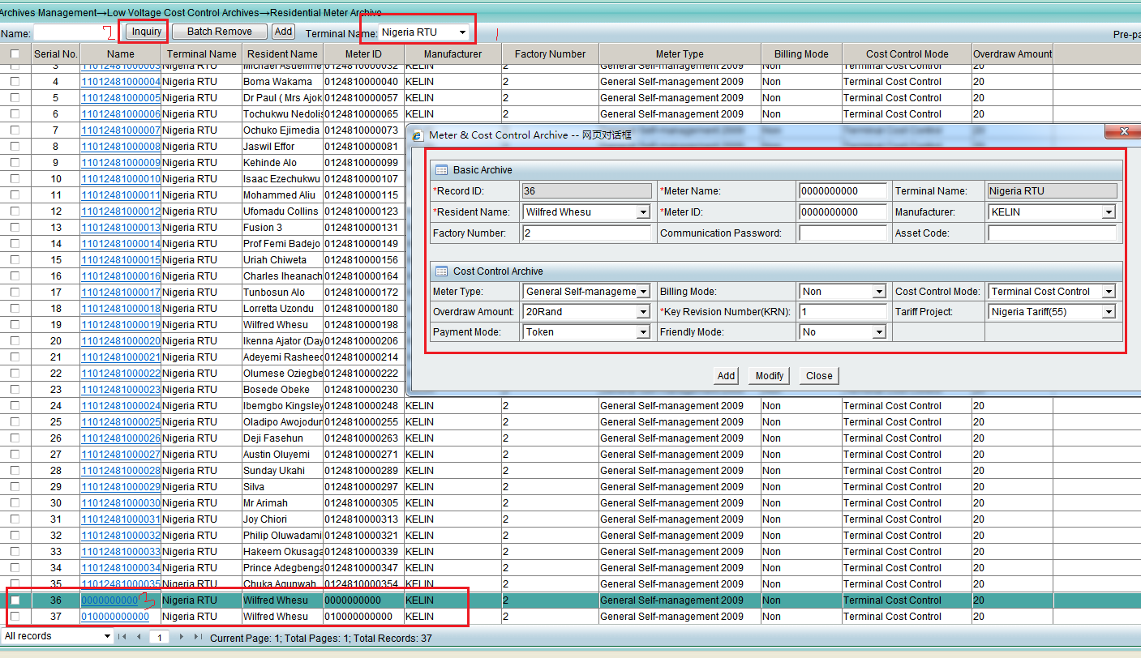

DRN Check，如果输入带校验位的表号，校验位错误会提示“Luhn digit error in the DRN number”.

DRN Check, if you enter the meter S/N with wrong parity bit, you are then prompted with “Luhn digit error in the DRN number”.

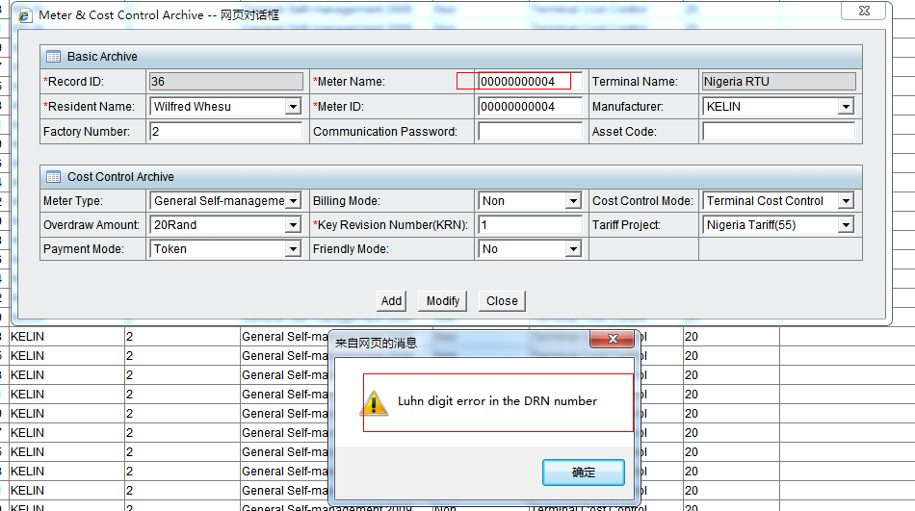

## 三、居民售电 III. Residential Vending

### 3.1 居民售电业务 3.1 Residential vending business

完成常用售电业务，如缴费、开户、销户操作。

To implement normal vending business such as payment, opening an account and close an account.

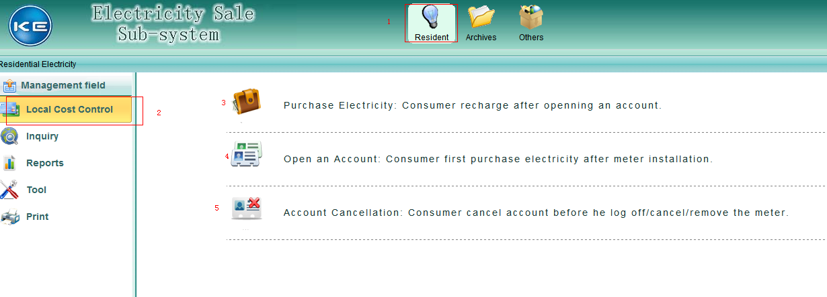

### 3.2 售电 Vending

点击Purchase Electricity，进入售电页面

Click “Purchase Electricity” to enter the vending page.

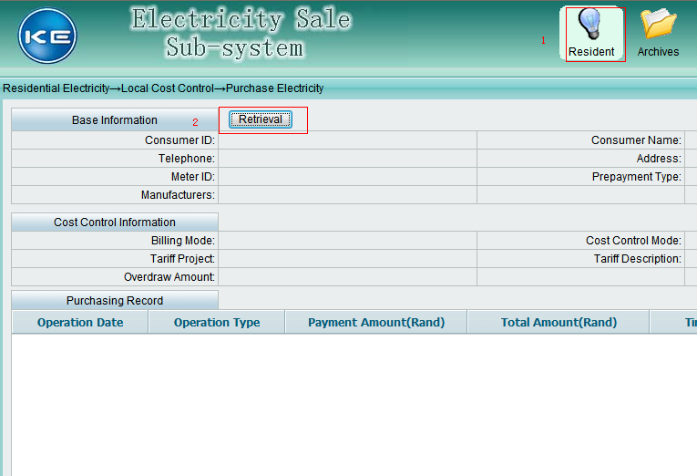

点击Retrieval按钮，根据Utility，MeterId，ConsumerName，ConsumerID等条件查询电表信息，点击Inquiry按钮，左下角选择All Records，鼠标拉到最后，我们能看到测试电表，双击该行，或者选中该行点击Confirm按钮。

Click “Retrieval” and set up the query conditions such as Utility, Meterld, ConsumerName and ConsumerID. Click “Inquiry” and select “All Records” on bottom left. Choose the tested meter and double click on the row or select and click “Confirm”.

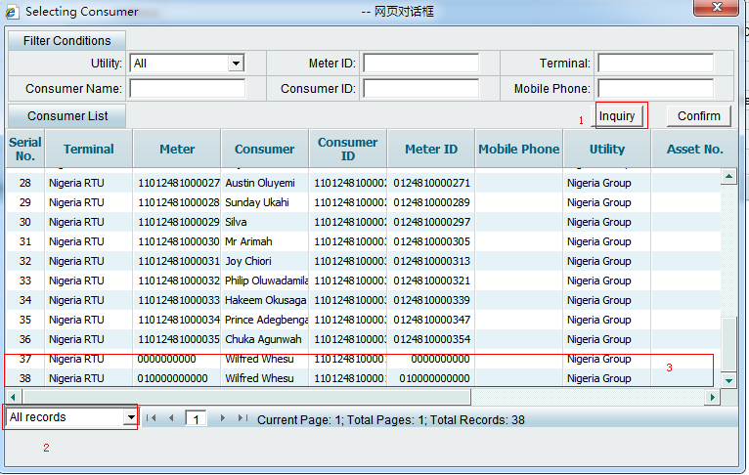

进入缴费操作页面，如下图

Enter the payment page as shown below.

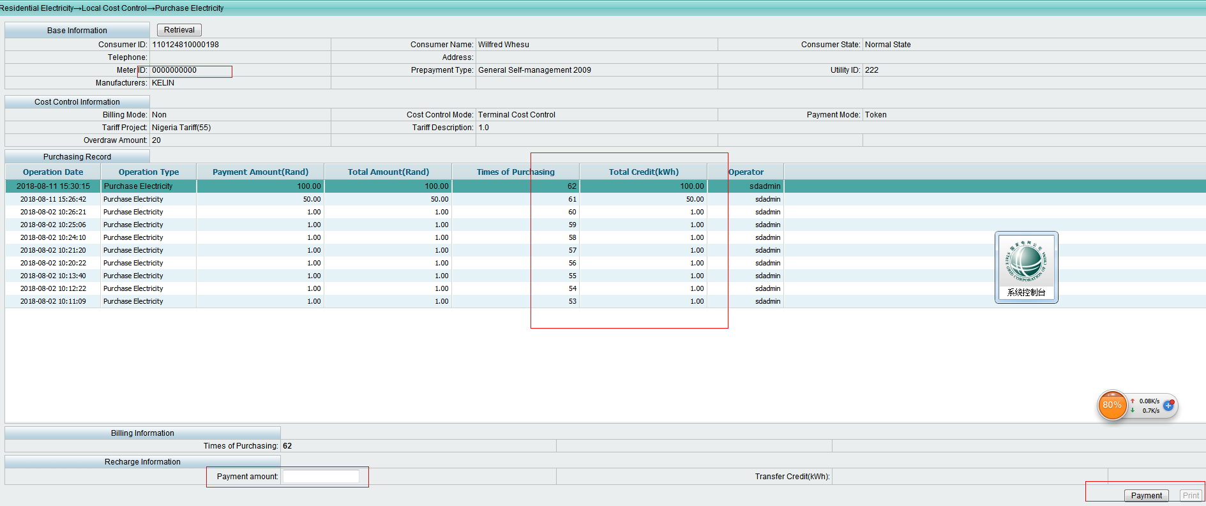

输入缴费金额100，计算缴费电量，生成缴费token，如下图

Enter payment amount 100 and calculate the corresponding kWh and generate a payment token as follows:

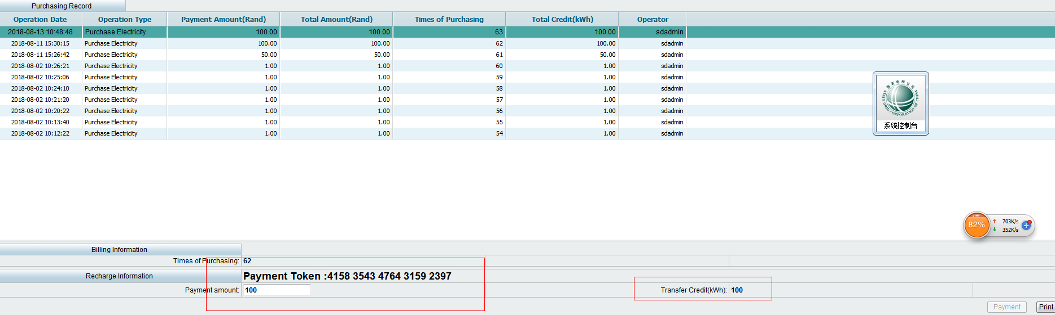

点击Print按钮，弹出售电小票预览界面，页面采用IE兼容模式，点击打印按钮，会弹出选择打印机界面，此处使用pos58类型打印机打印售电小票。

Click “Print” and you will be prompted with a window to preview the receipt. You should set the browser as IE compatible mode and print the receipt through pos58 type printer.

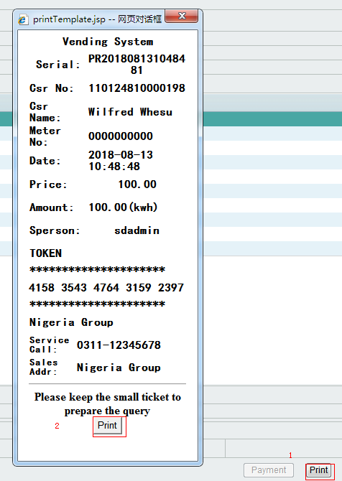

### 3.3 开户 Opening an account

选择Open an account，进入开户操作，选择电表010000000000，

Choose “Open an account” to enter the page and choose meter 010000000000

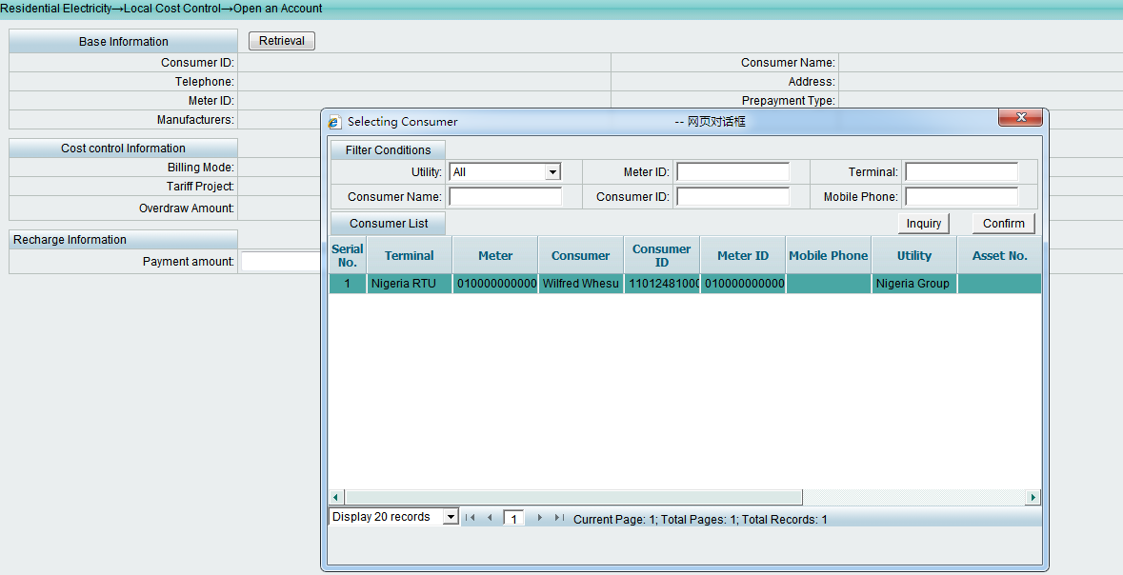

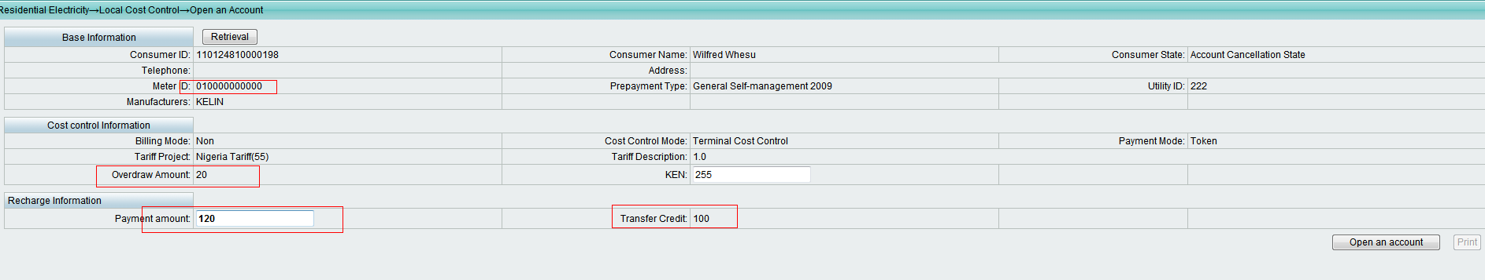

### 3.4 销户 Closing an account

选中需要销户的电表，登记当前余额，点击Account Cancellation，进行销户，清空电表电量。

Choose the meter that need to be cancelled and register the current balance, click “Account Cancellation” to close the account and empty the meter credit.

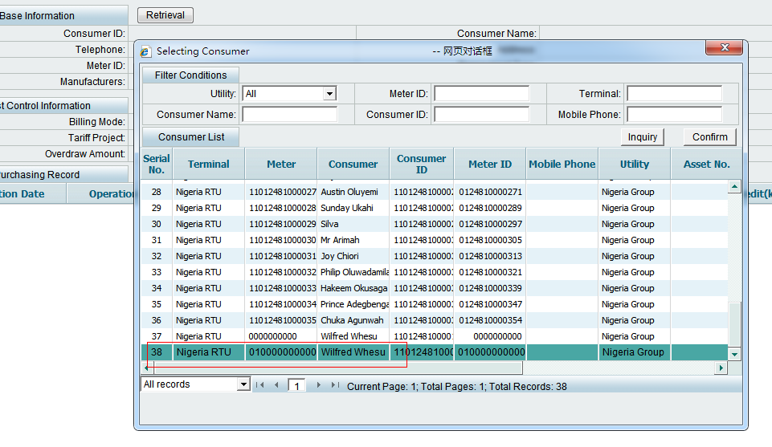

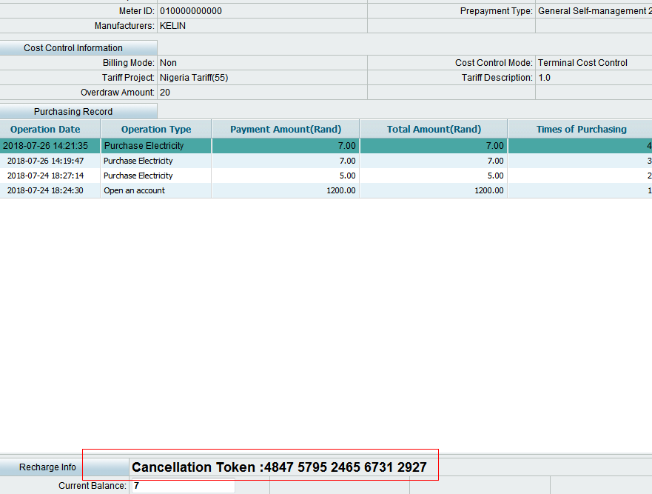

## 四、Inquiry

查询操作员售电记录、客户信息、费率参数信息。

Query operator vending records, customer and tariff parameter information.

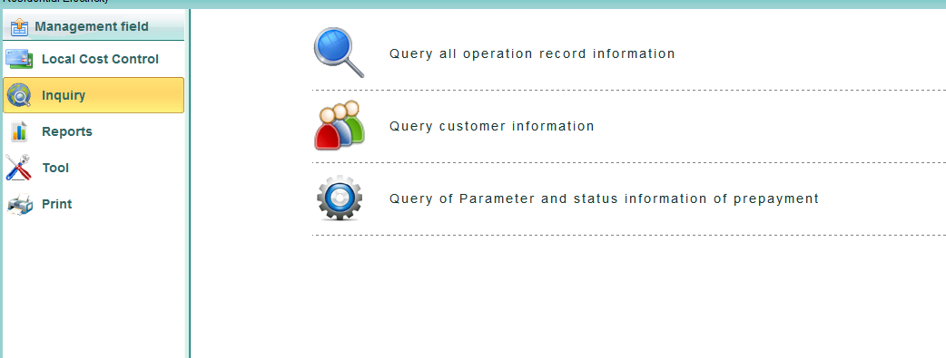

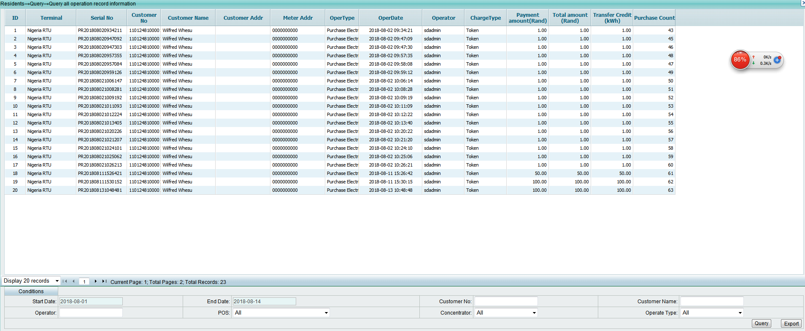

## 五、Reports V. Reports

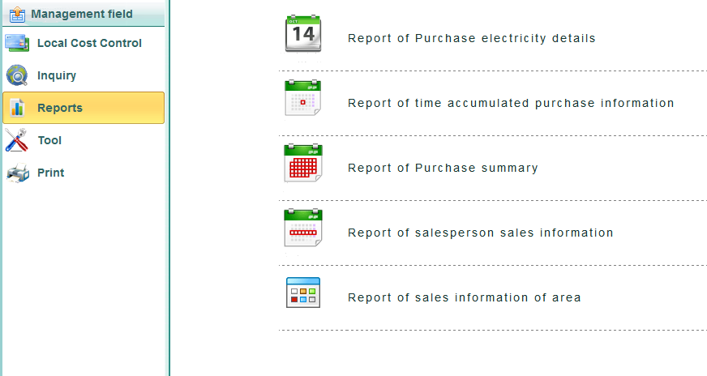

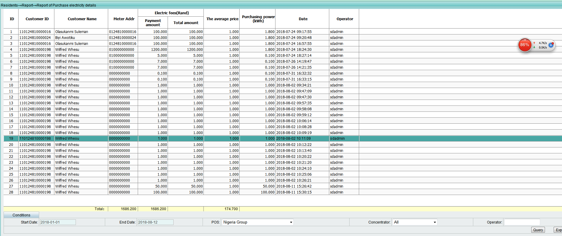

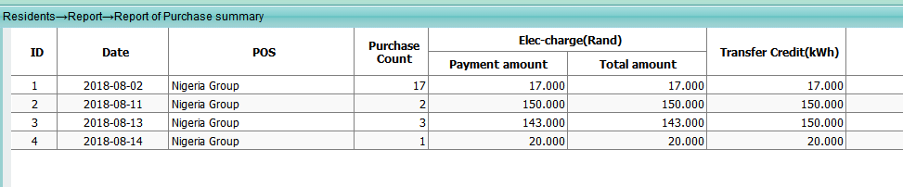

## 六、Tool VI. Tool

Tool-->stsTool

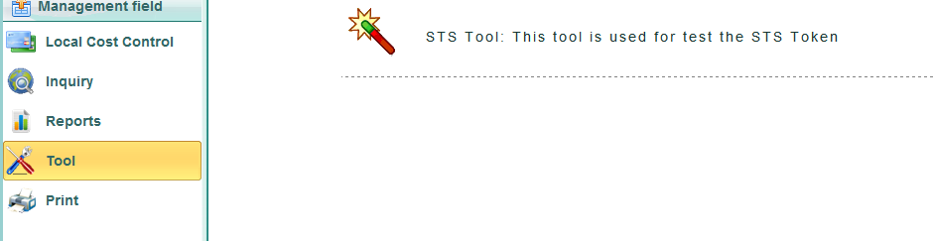

sts工具菜单提供设置电表的class1以及class2相关参数信息，生成对应token操作。

The sts tool menu provides parameters information to configure the class 1 and class 2, and

generates the corresponding token operation.

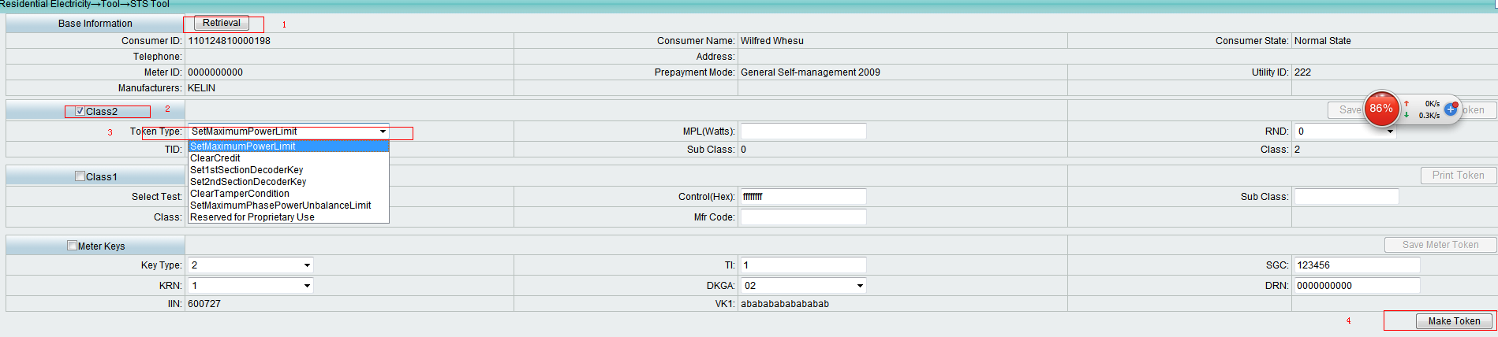

## 七、测试 VII. Test

### 7.1 SetMaximumPowerLimit

MPL:1000 获取tokenId时日期值为"2004-03-28 09:01:00"

MPL:1000 The date value is "2004-03-28 09:01:00" when getting the token.

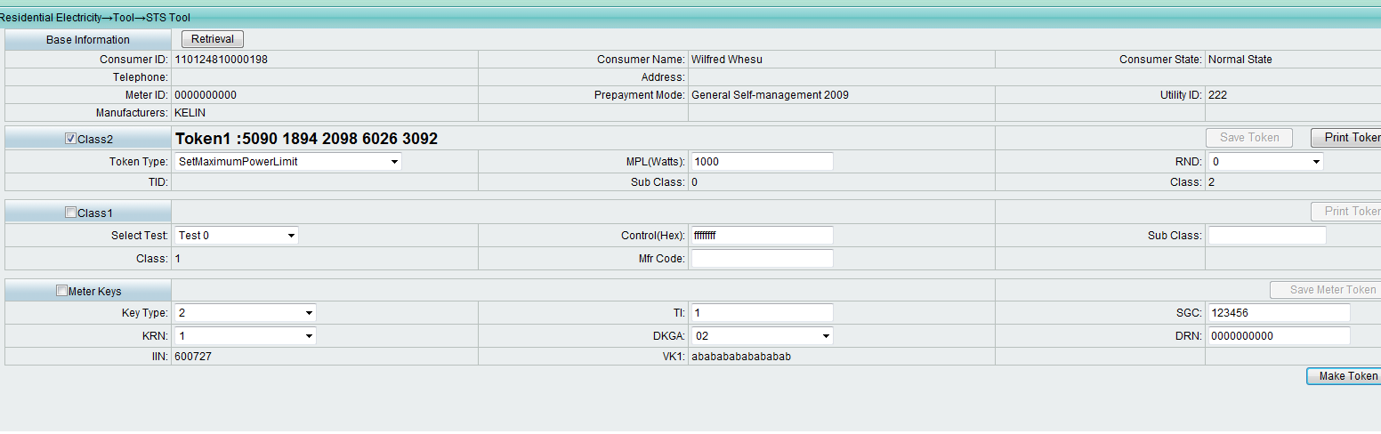

### 7.2 ClearCredit

Register:65535. 获取tokenId时日期值为"2004-03-28 09:15:00"

Register:65535. The date value is "2004-03-28 09:15:00" when getting the token.

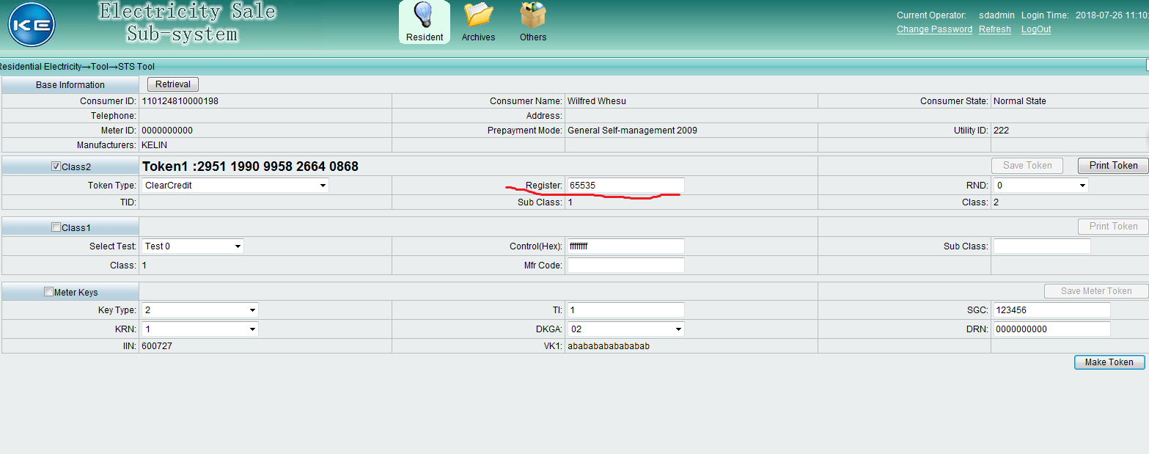

### 7.3 Set1ndSectionDecoderKey

New Meter Key (随便填，软件需要必填)， New Tariff Index(填2)

New Meter Key: Fill in whatever you want and you are required to fill in something.

New Tariff Index: Fill in the blank with 2.

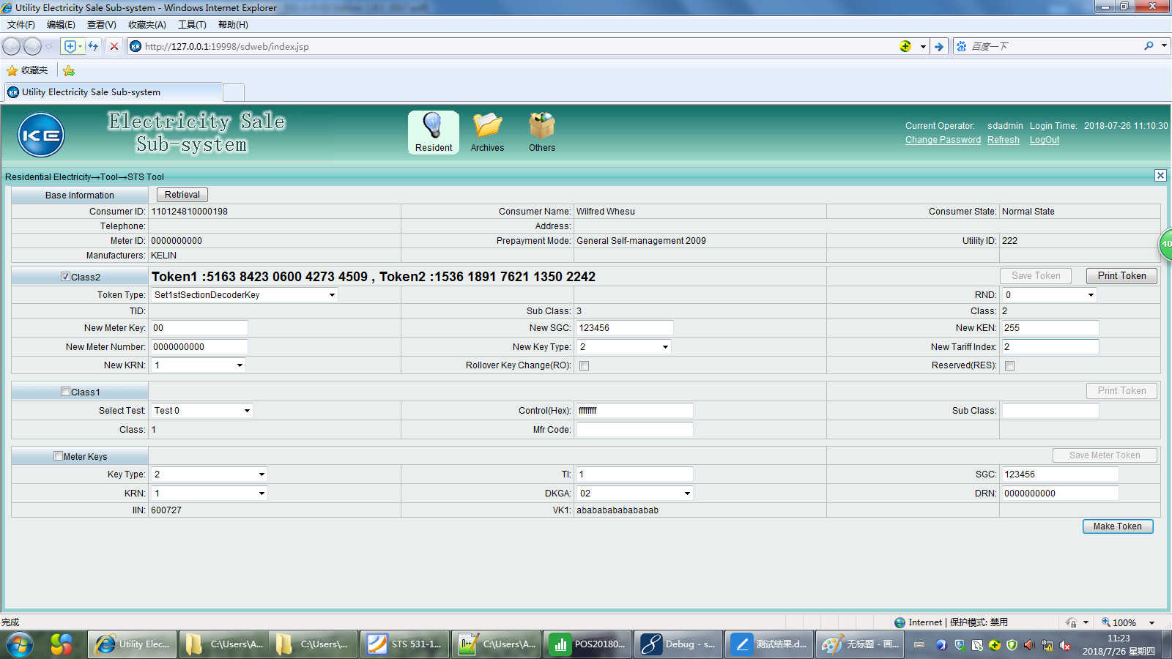

后台将tariff Index设置为2(测试时注意修改)，界面填1.

The software background sets the “tariff index” to “2”.

(Remember to change the tariff index when testing). Fill in the blank of “interface” with “1”.

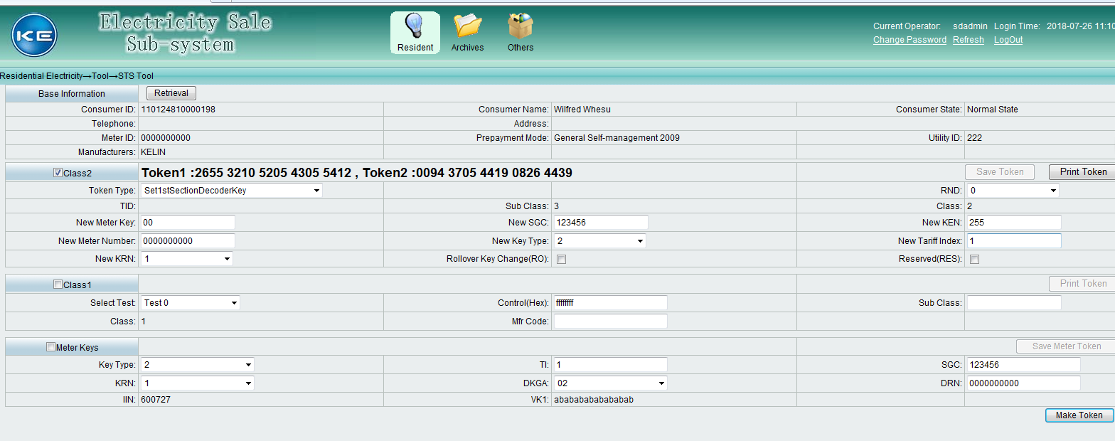

### 7.4 Set2ndSectionDecoderKey

同3 Implement the same process with 7.3.

### 7.5 ClearTamperCondition

Pad填0或不填 获取tokenId时日期值为"2004-03-28 10:00:00"

Fill the blank with “0”or nothing for the item “Pad”

The date value is "2004-03-28 10:00:00" when getting the token.

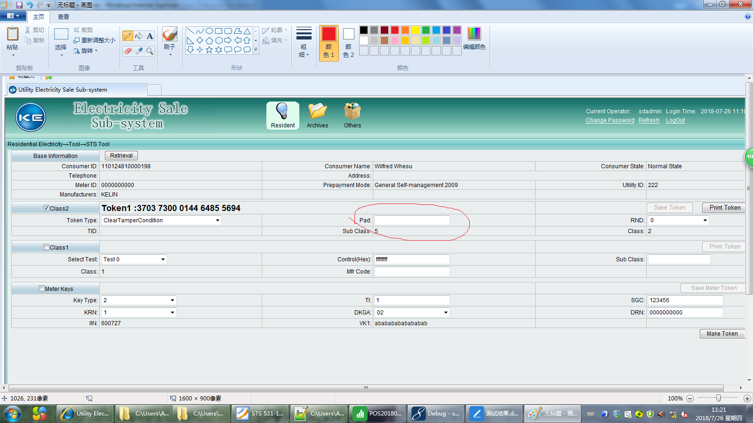

### 7.6 Set Maximum Phase Power Unbalance Limit

MPPUL:10 获取tokenId时日期值为"2004-03-28 10:20:00"

MPPUL:10 The date value is "2004-03-28 10:20:00" when getting the token.

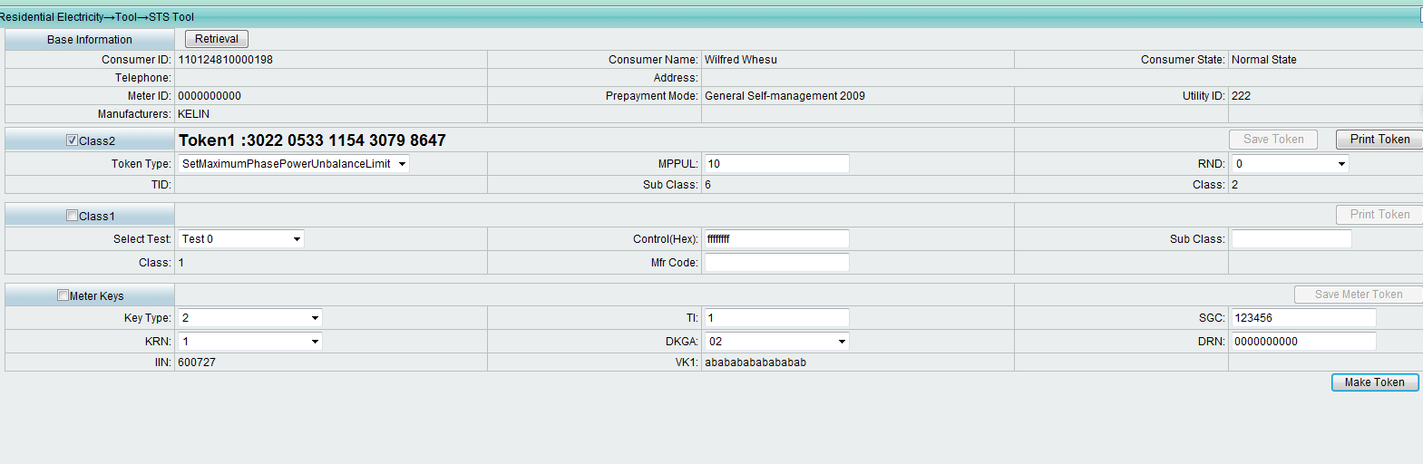

### 7.7 Reserved for Proprietary Use

### 7.8 缴费 Payment

transfer_amount = 0.1, 获取tokenId时日期值为"2004-03-01 13:55:00"

transfer_amount = 0.1, the date value is "2004-03-01 13:55:00" when getting the token.

[0001] - STS531-1-0-02: CTSA01 Test Step: 1

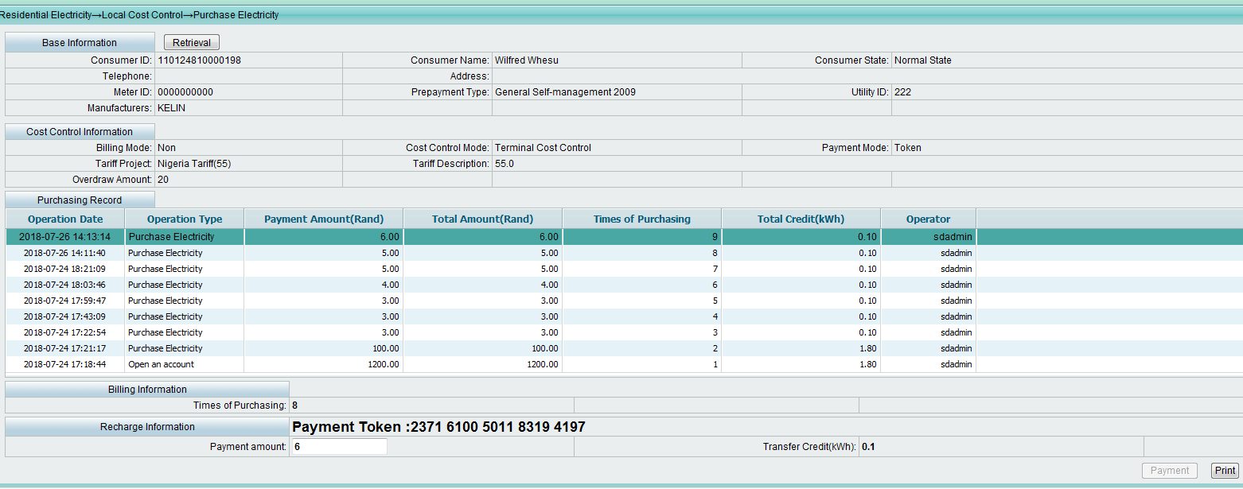

[0002] - STS531-1-0-02: CTSA01 Test Step: 2

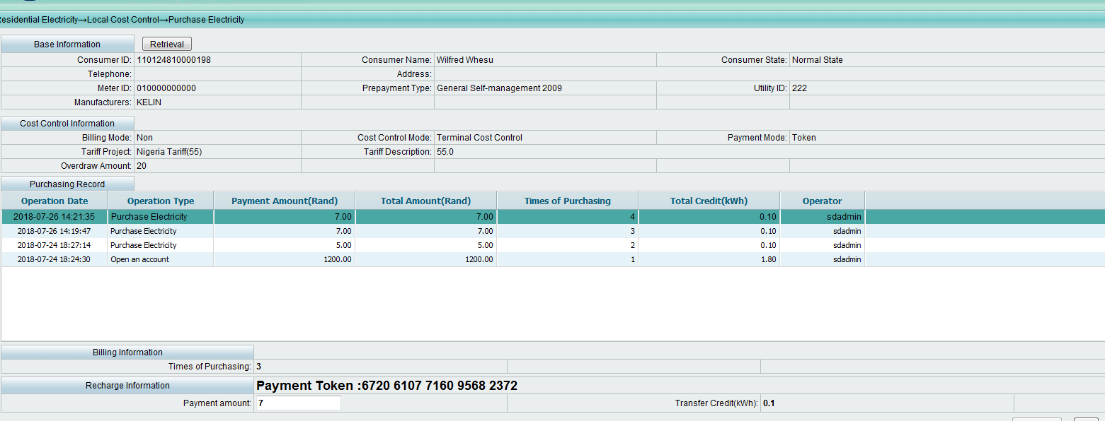

### 7.9 class1 Test

[0003] - STS531-1-0-02: CTSA02 Test Step: 1 (Control(Hex): 9个f)

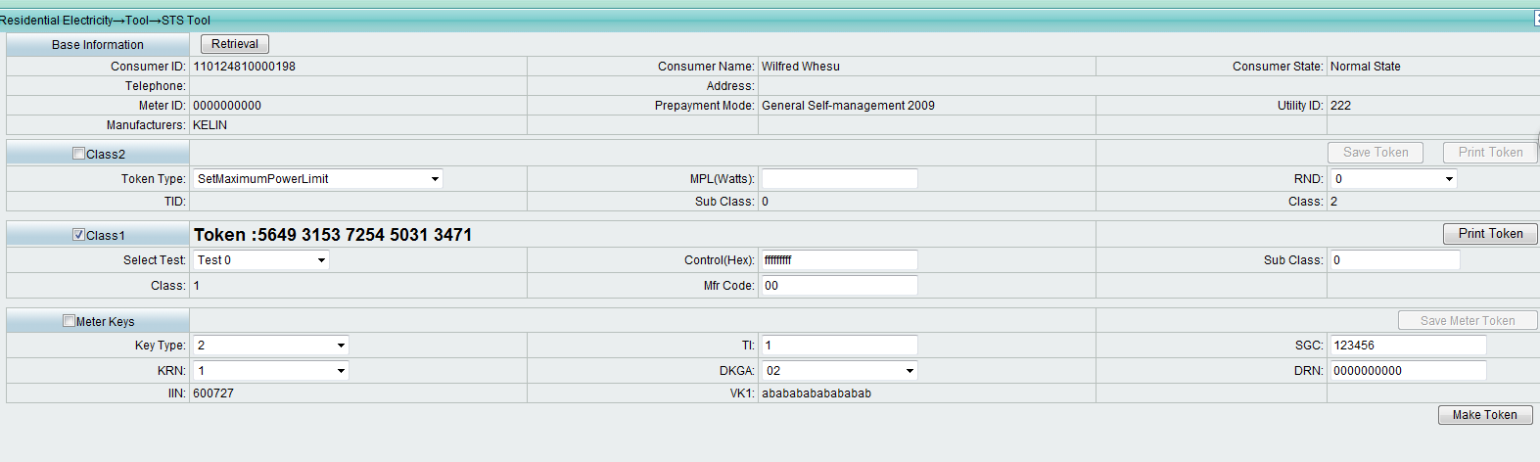

[0004] - STS531-1-0-02: CTSA02 Test Step: 2 (Control(Hex): 7个f)

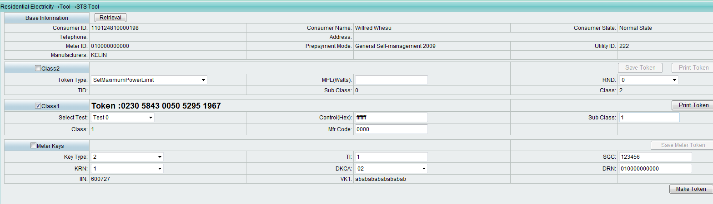

### 7.10 class2 Test

[0005] - STS531-1-0-02: CTSA03 Test Step: 1



[0006] - STS531-1-0-02: CTSA04 Test Step: 1

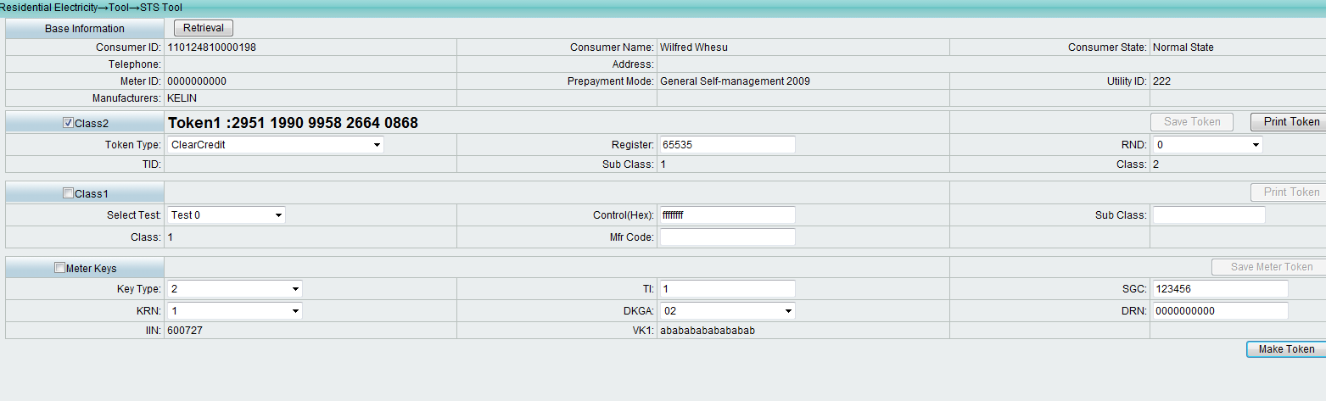

[0007] - STS531-1-0-02: CTSA04 Test Step: 2

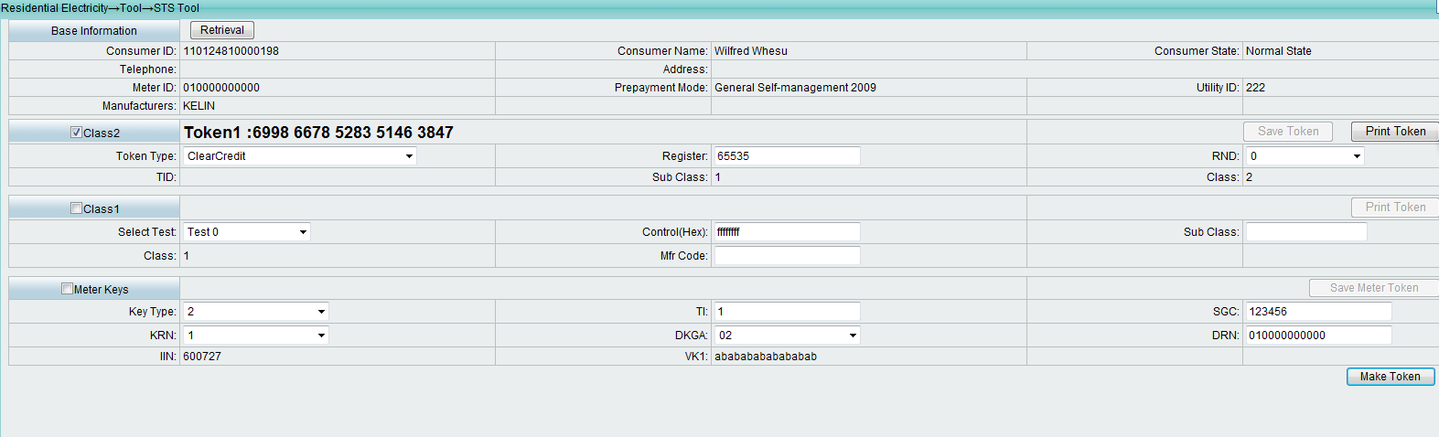

[0008] - STS531-1-0-02: CTSA05 Test Step: 1

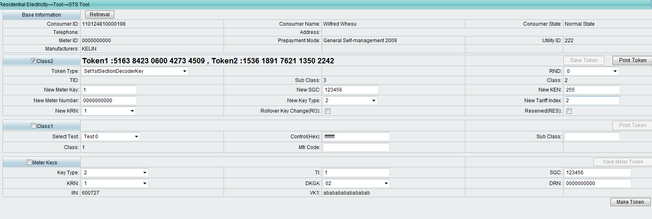

[0009] - STS531-1-0-02: CTSA05 Test Step: 2

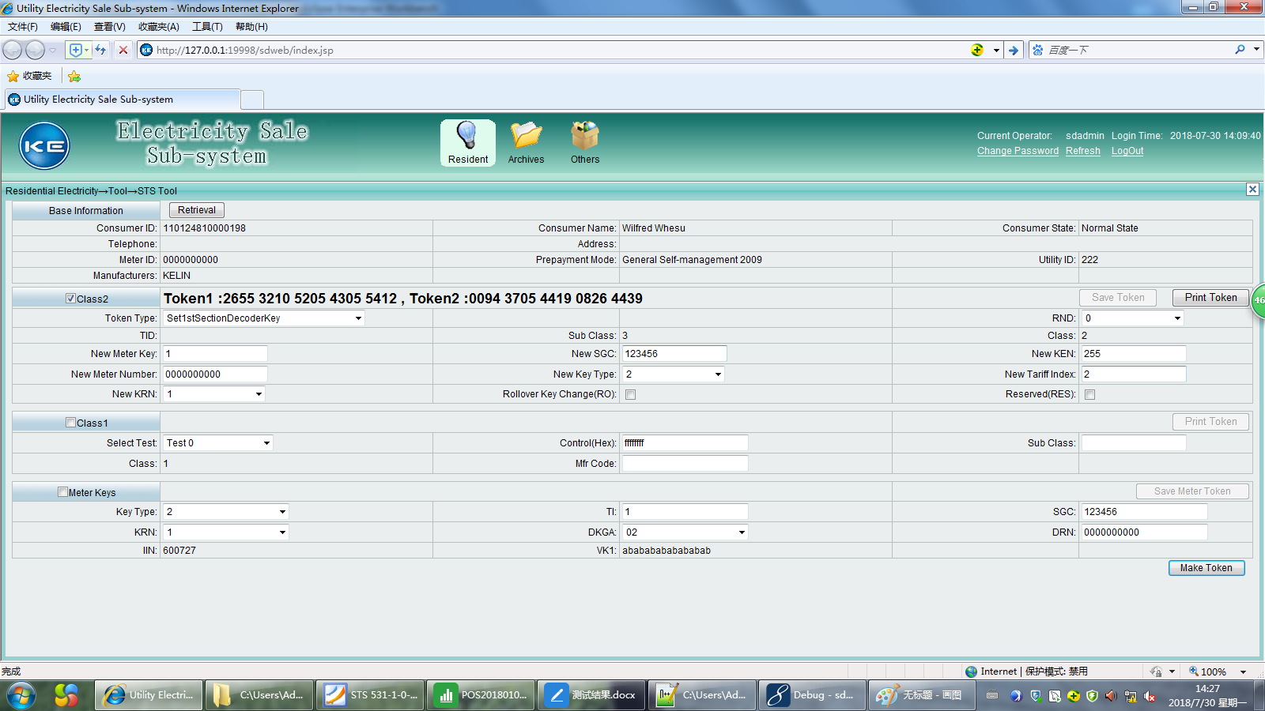

[0010] - STS531-1-0-02: CTSA05 Test Step: 3

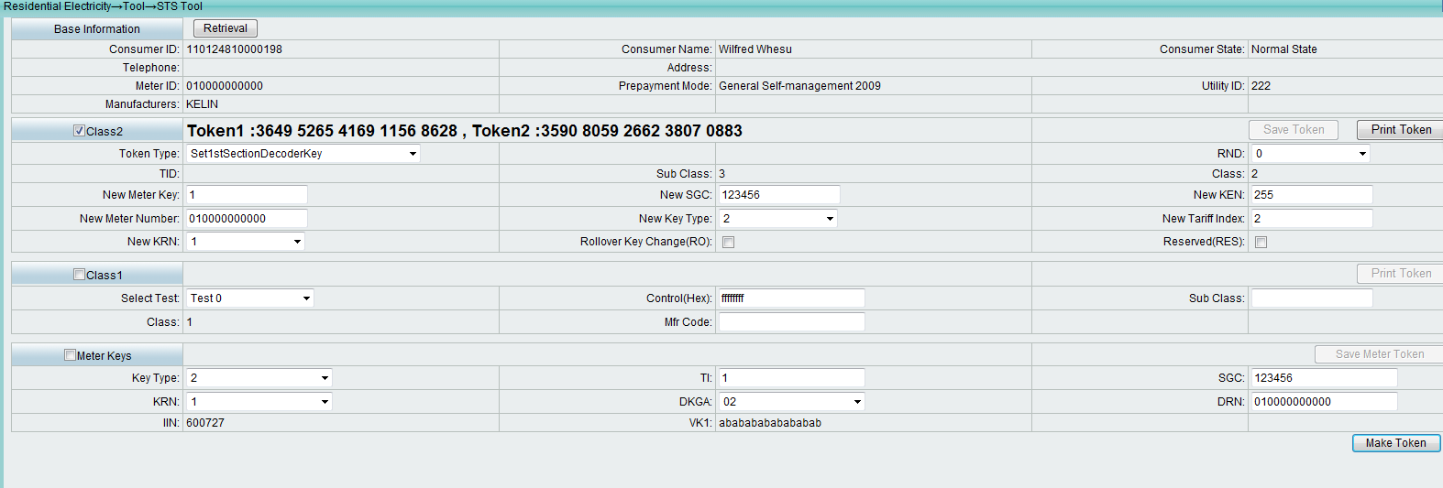

[0011] - STS531-1-0-02: CTSA06 Test Step: 1

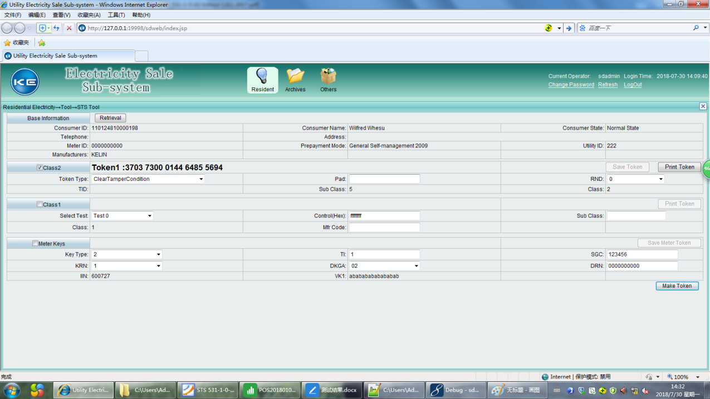

[0012] - STS531-1-0-02: CTSA07 Test Step: 1

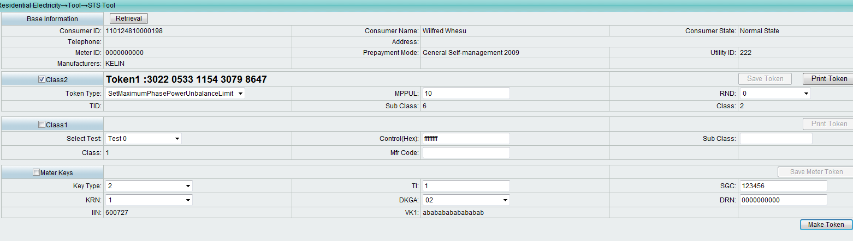

[0013] - STS531-1-0-02: CTSA09 Test Step: 1

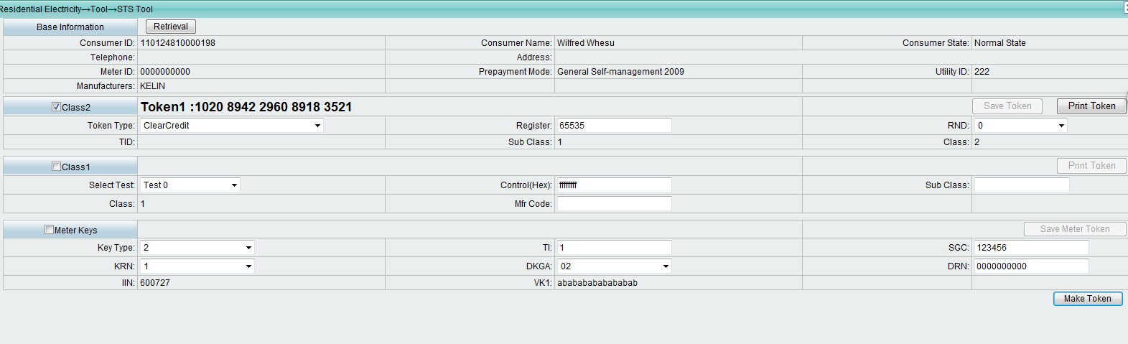

0014] - STS531-1-0-02: CTSA09 Test Step: 2

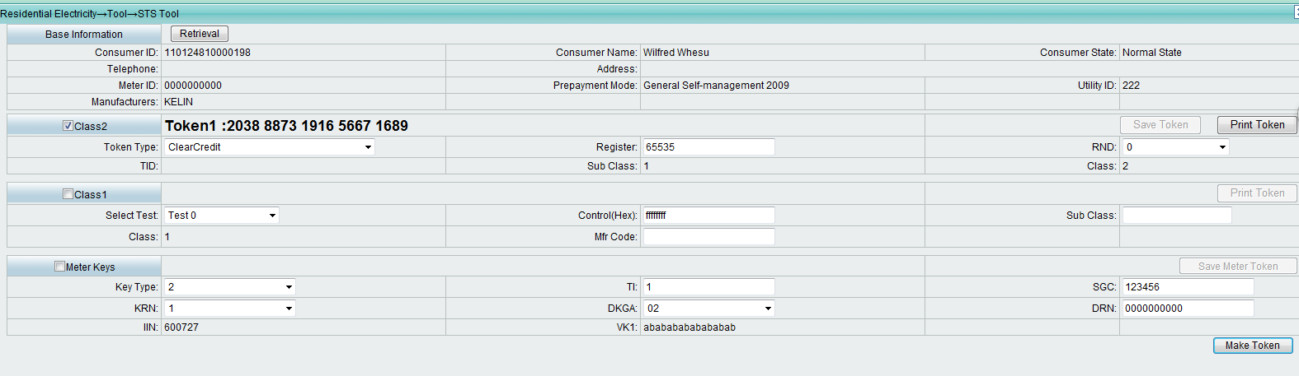

[0015] - STS531-1-0-02: CTSA09 Test Step: 3

注意ClearCredit目前没有存库，所以相同时间产生的token是一样的，实际需要时间加一分钟(tid+1)，测试时web端时间2004-03-29 00:03服务器的时间要+1分钟才行。

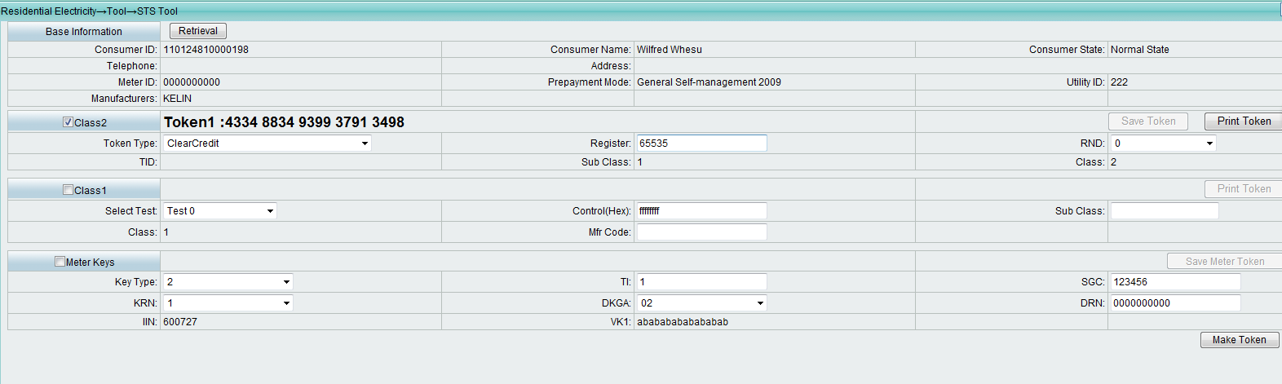

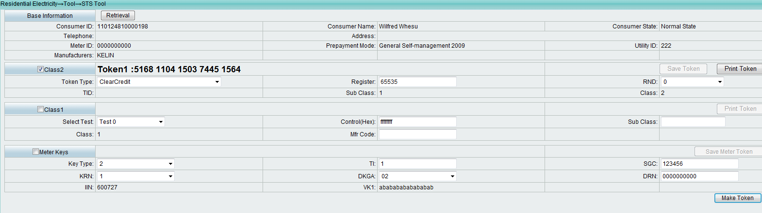

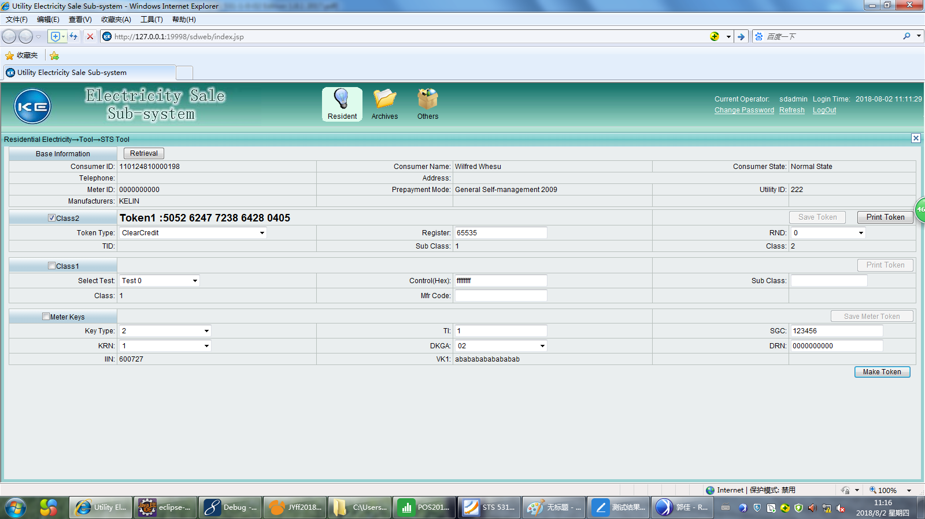

[0015] - STS531-1-0-02: CTSA09 Test Step: 4

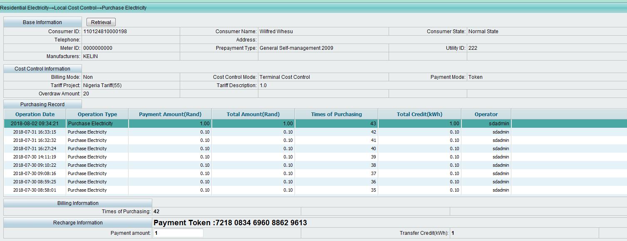

[0015] - STS531-1-0-02: CTSA09 Test Step: 5

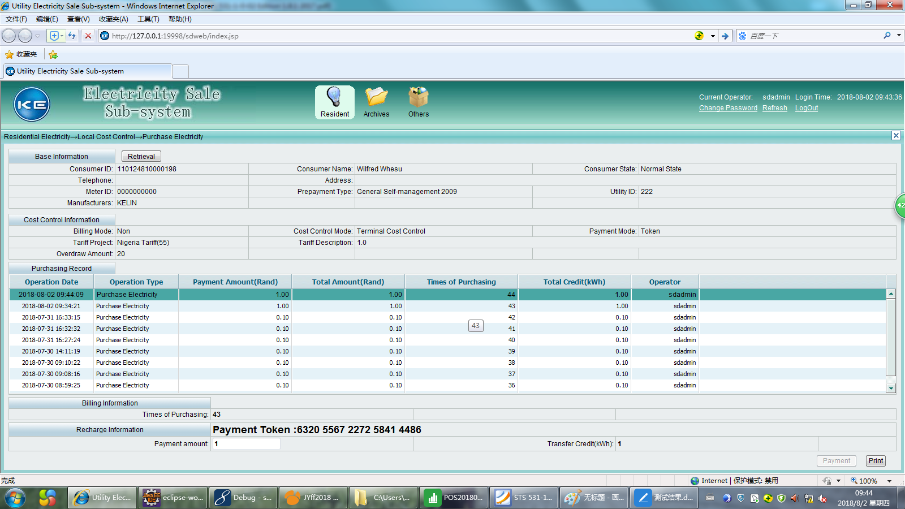

[0015] - STS531-1-0-02: CTSA09 Test Step: 6

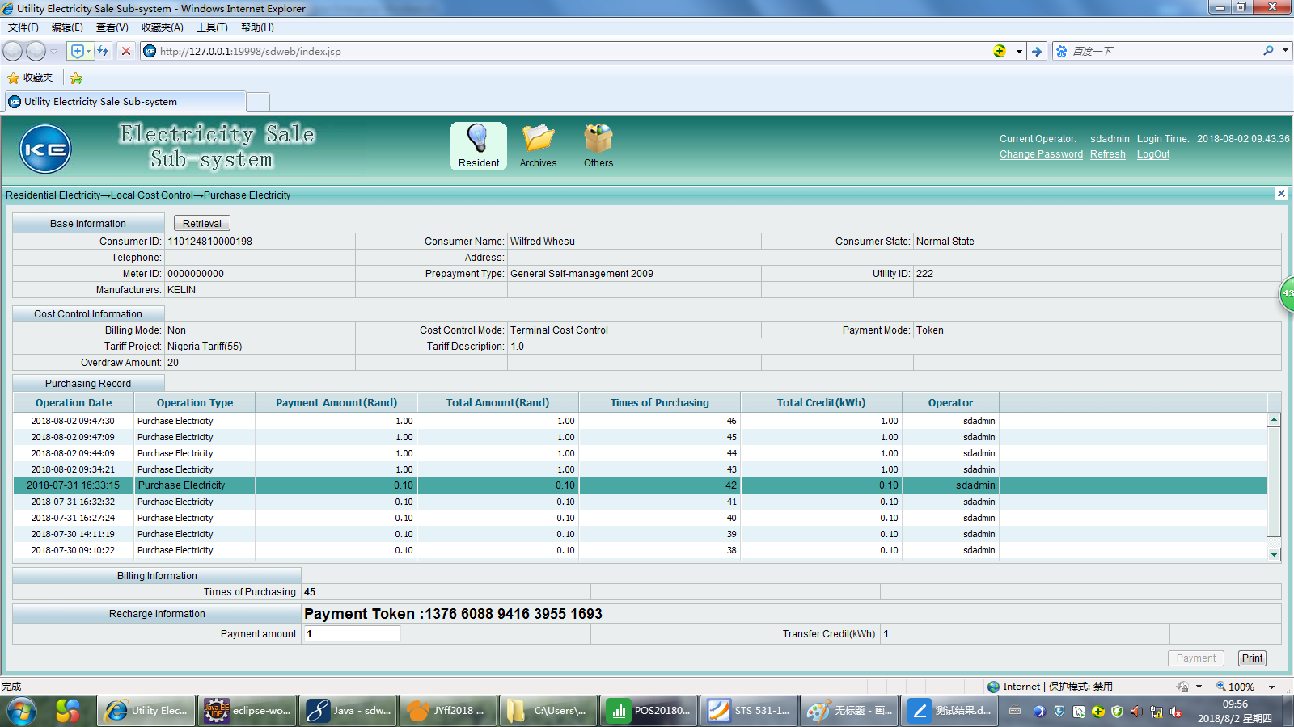

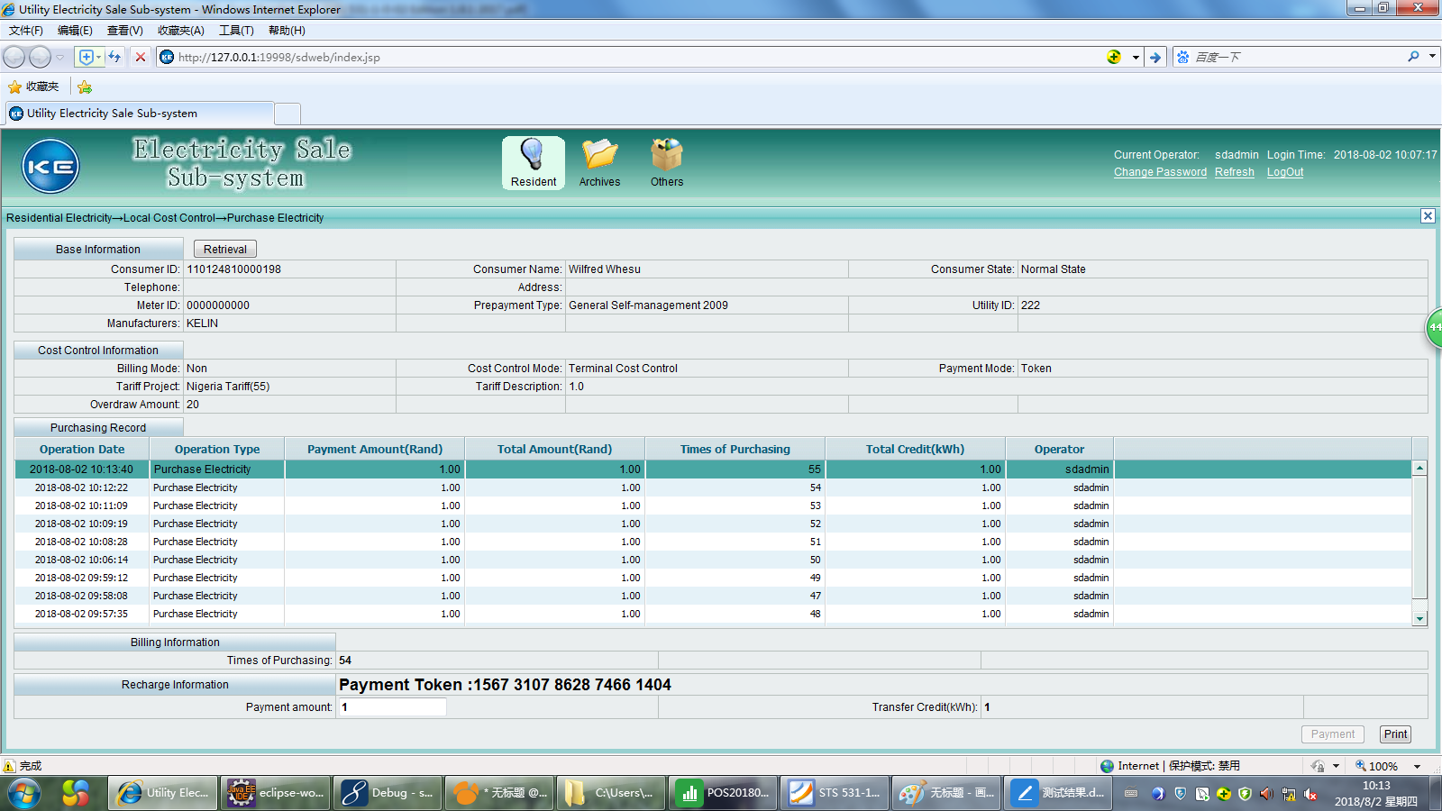

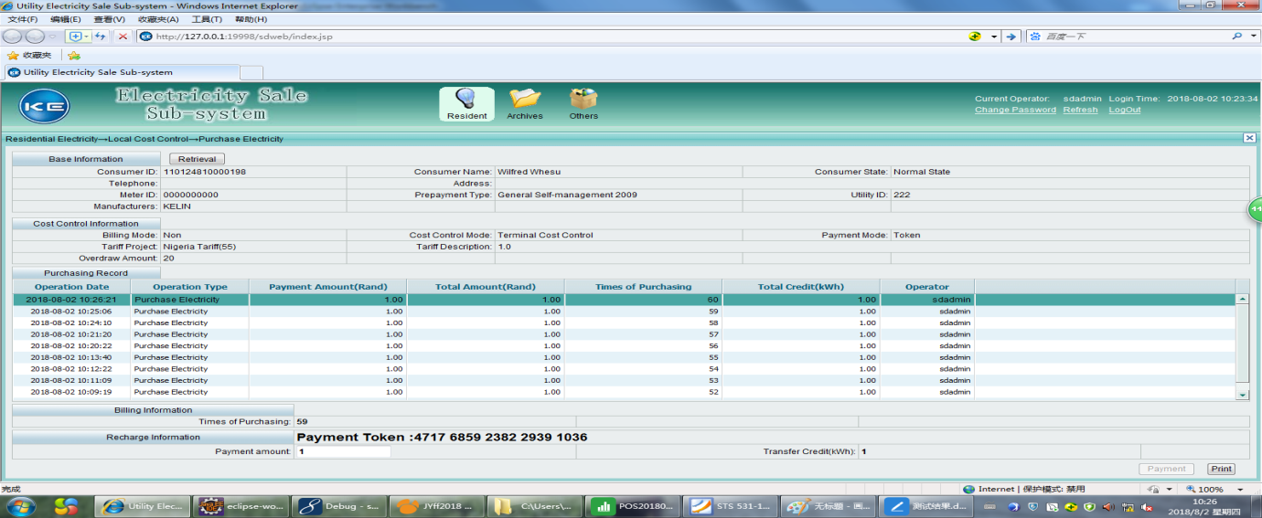

### 7.11 Other tests

[0016] - STS531-1-0-02: CTSA10 Test Step: 1 ----

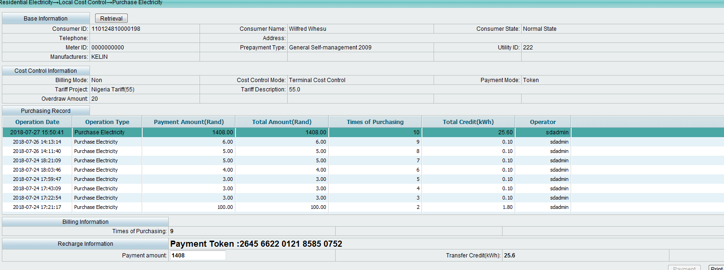

[0017] - STS531-1-0-02: CTSA10 Test Step: 2

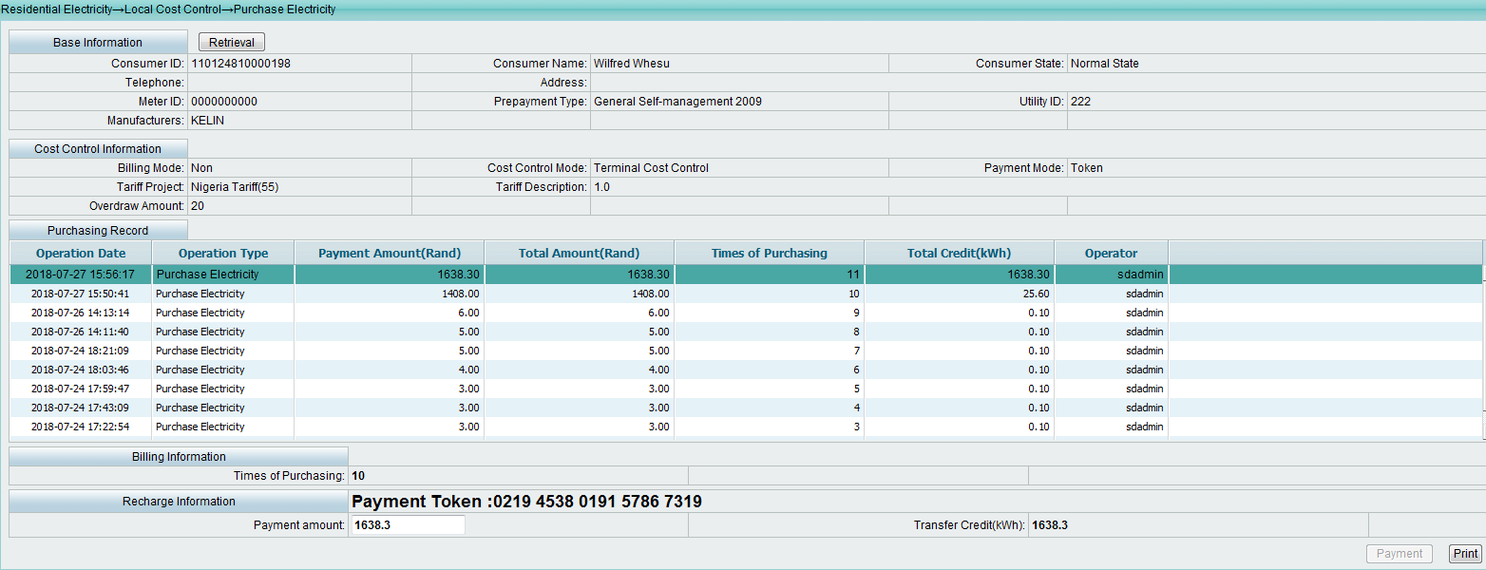

[0018] - STS531-1-0-02: CTSA10 Test Step: 3

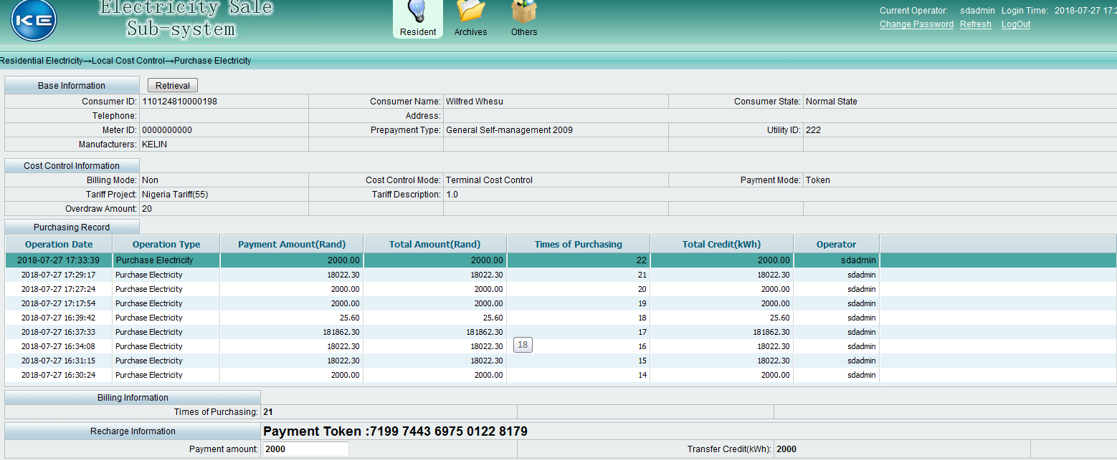

[0019] - STS531-1-0-02: CTSA10 Test Step: 4

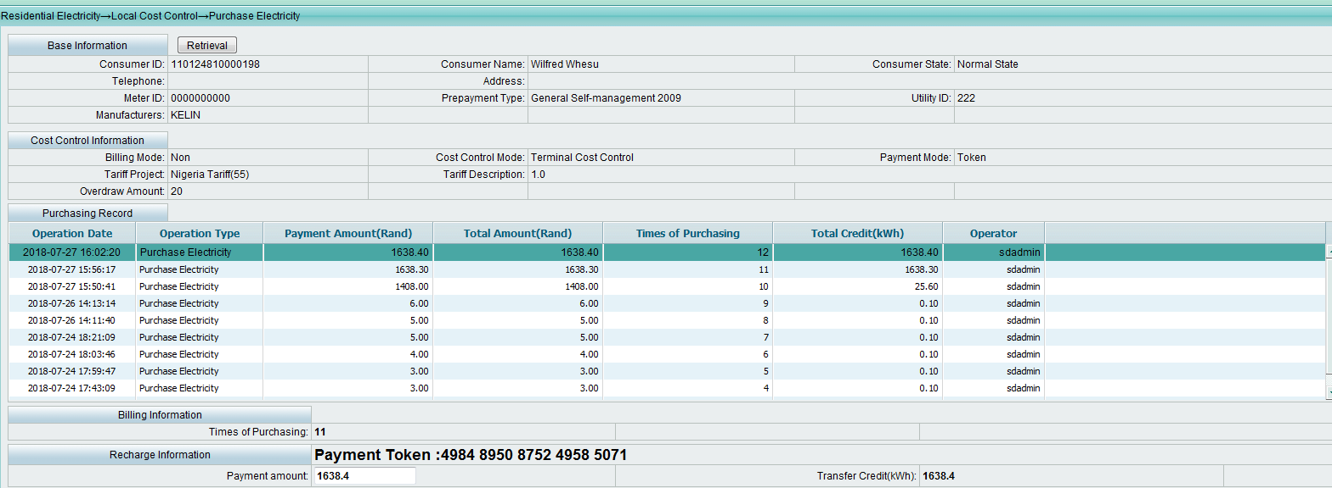

[0020] - STS531-1-0-02: CTSA10 Test Step: 5

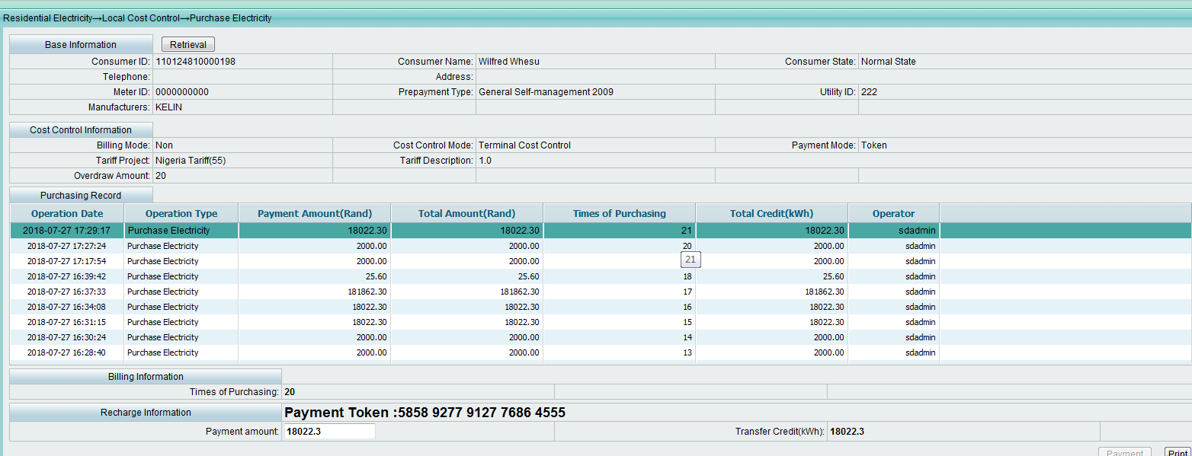

[0021] - STS531-1-0-02: CTSA10 Test Step: 6

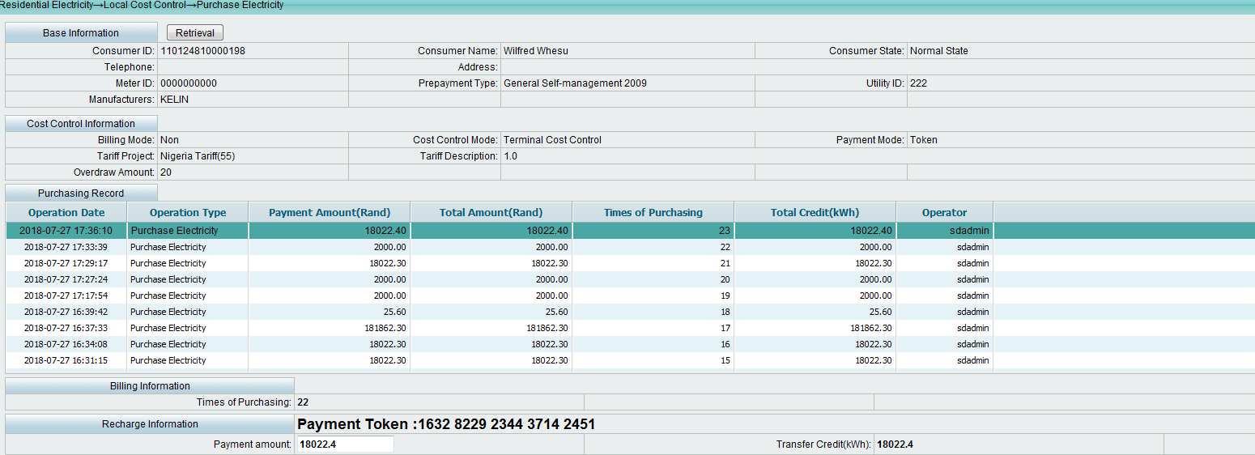

[0022] - STS531-1-0-02: CTSA10 Test Step: 7

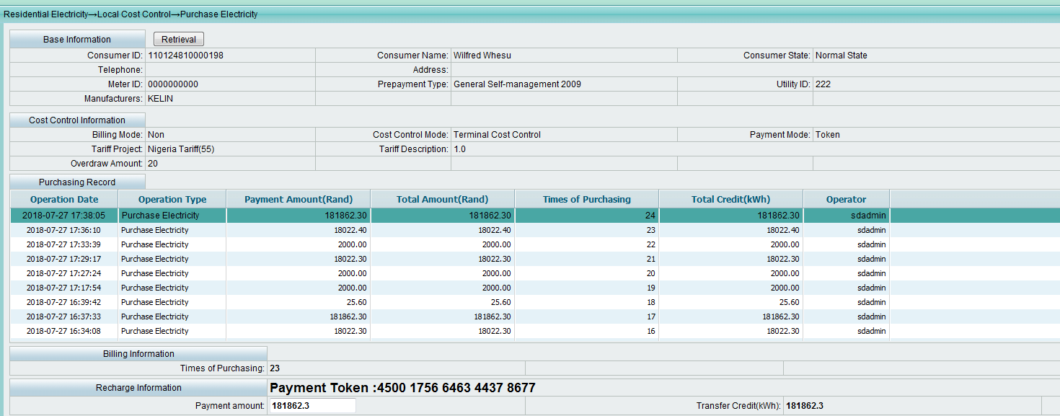

[0023] - STS531-1-0-02: CTSA10 Test Step: 8

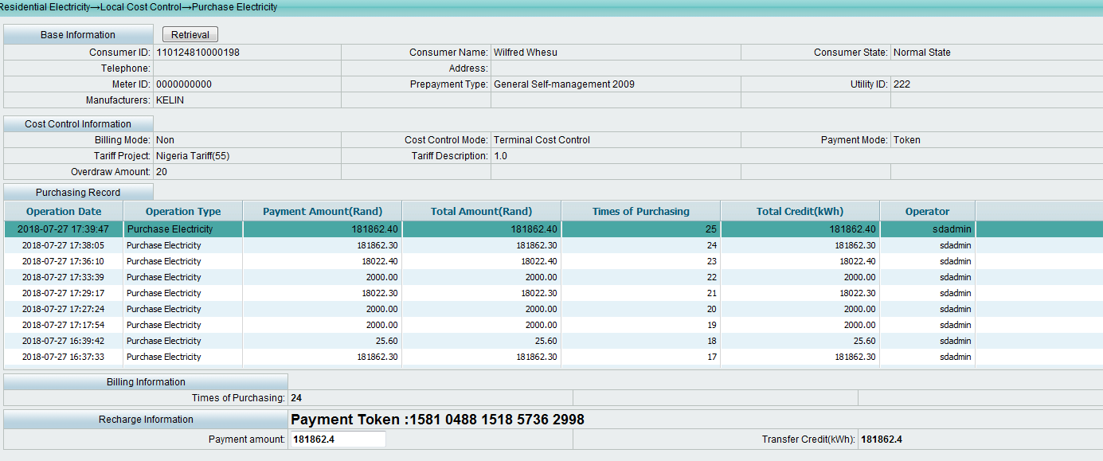

[0024] - STS531-1-0-02: CTSA10 Test Step: 9

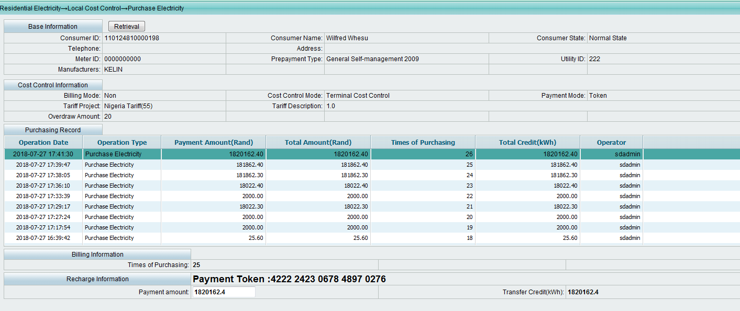

[0025] - STS531-1-0-02: CTSA11 Test Step: 1(软件明文算法，不走加密流程)

The software adopts clear text algorithm and encryption process is not needed.

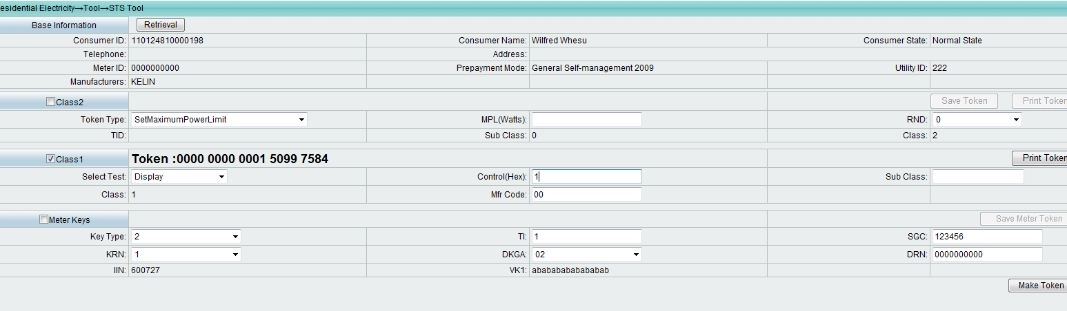

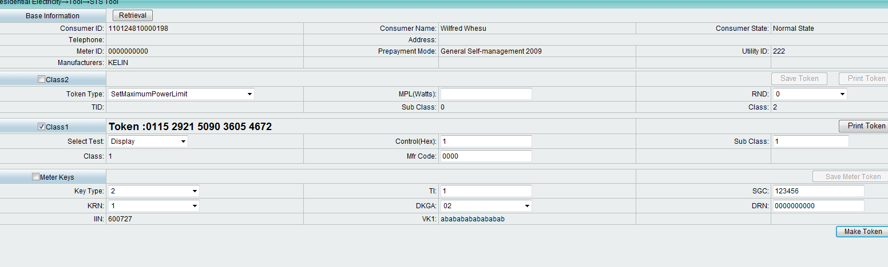

[0026] - STS531-1-0-02: CTSA11 Test Step: 2

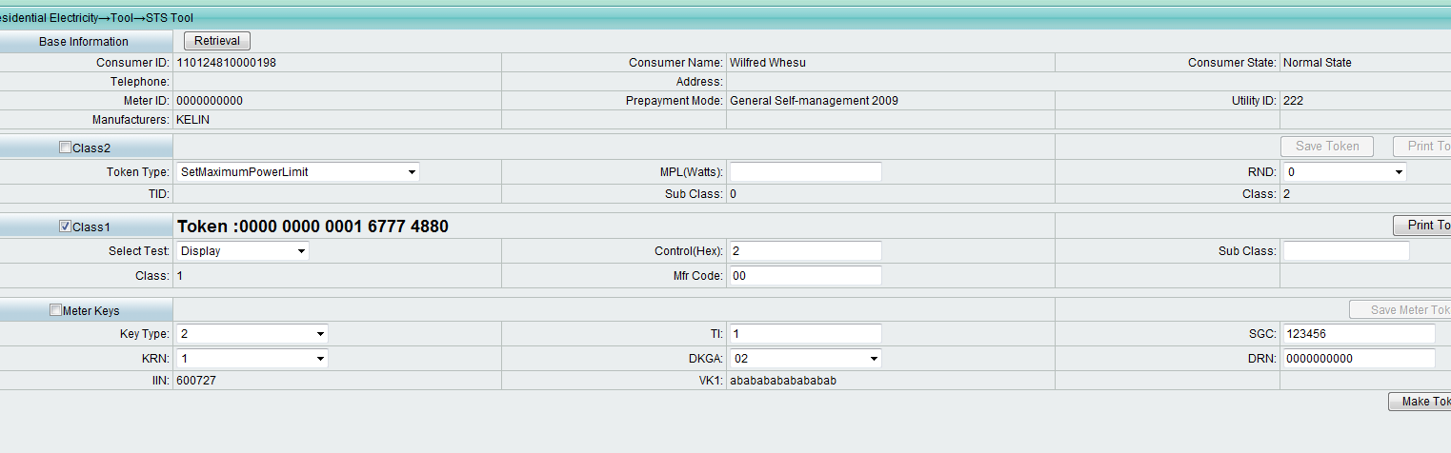

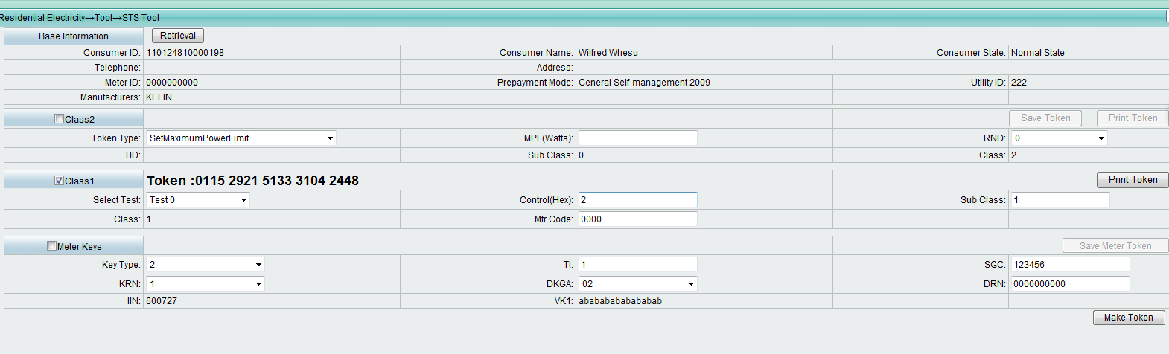

[0027] - STS531-1-0-02: CTSA11 Test Step: 3

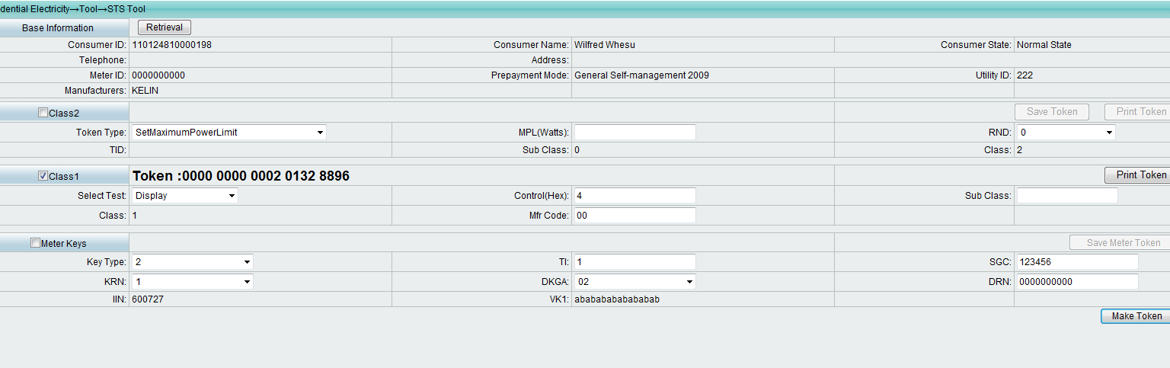

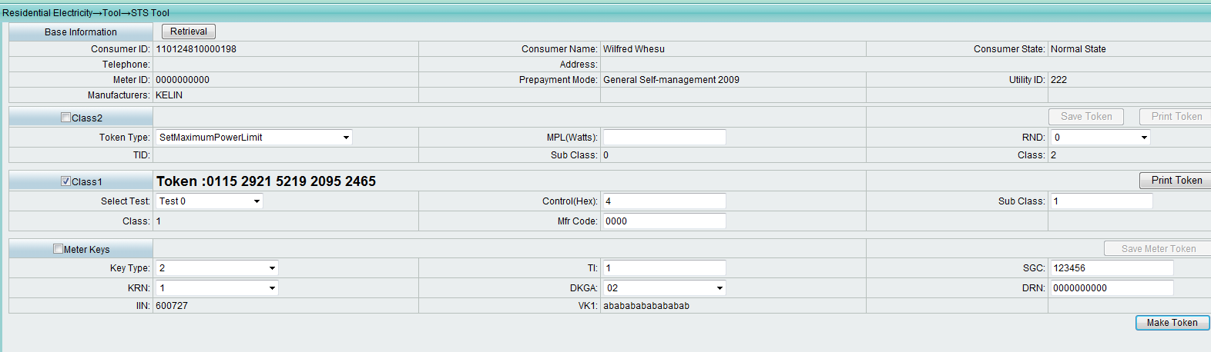

[0028] - STS531-1-0-02: CTSA11 Test Step: 4

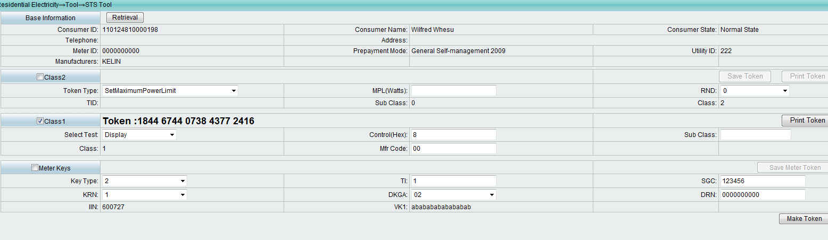

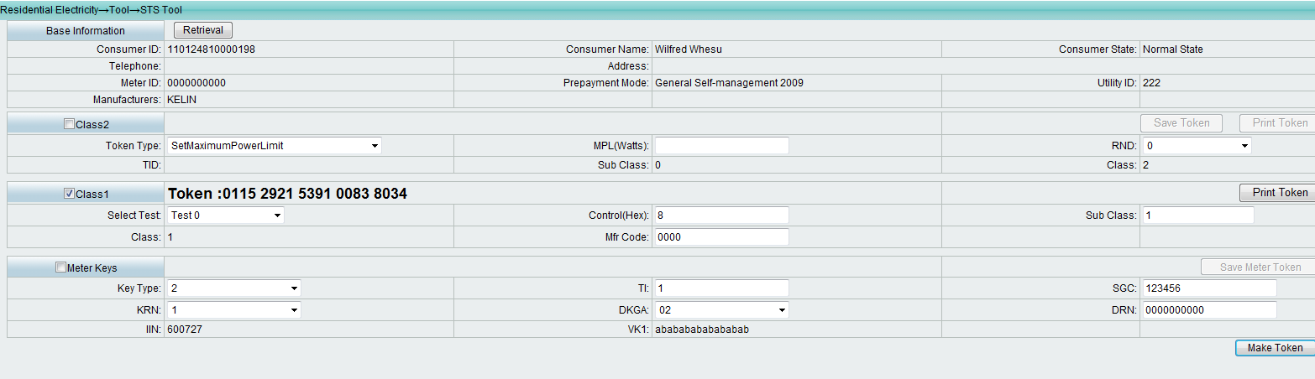

[0029] - STS531-1-0-02: CTSA11 Test Step: 5

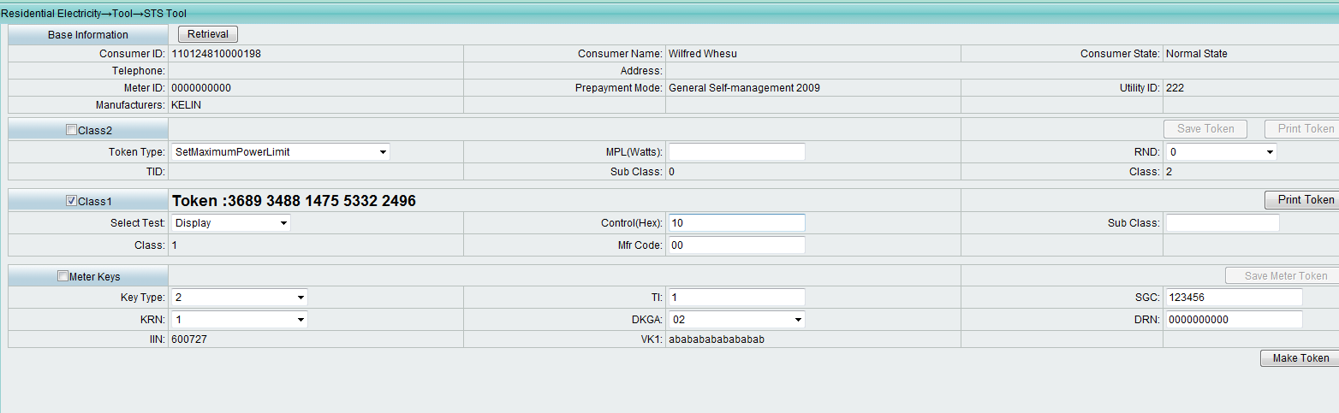

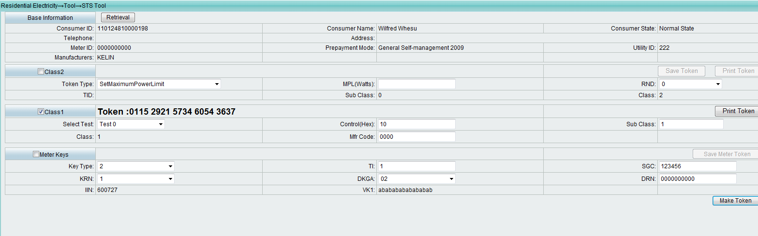

[0030] - STS531-1-0-02: CTSA11 Test Step: 6

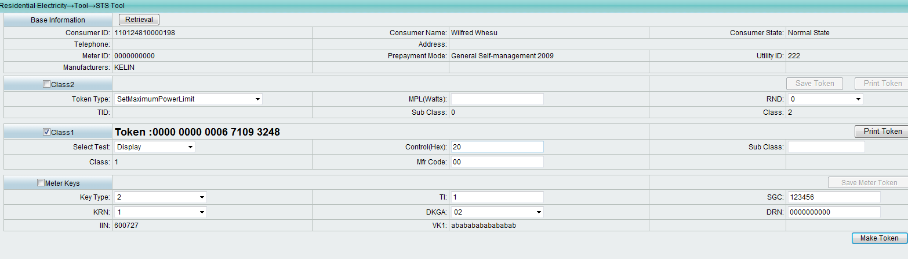

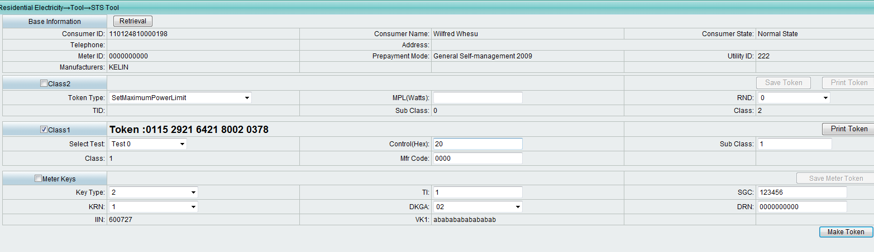

[0031] - STS531-1-0-02: CTSA11 Test Step: 7

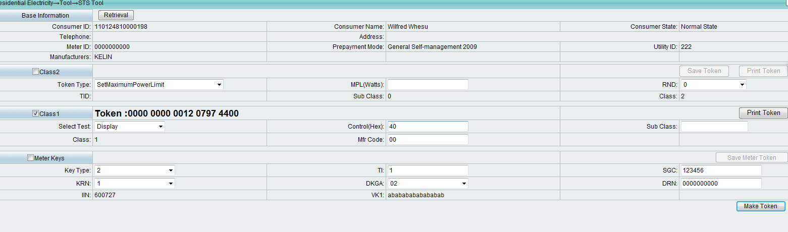

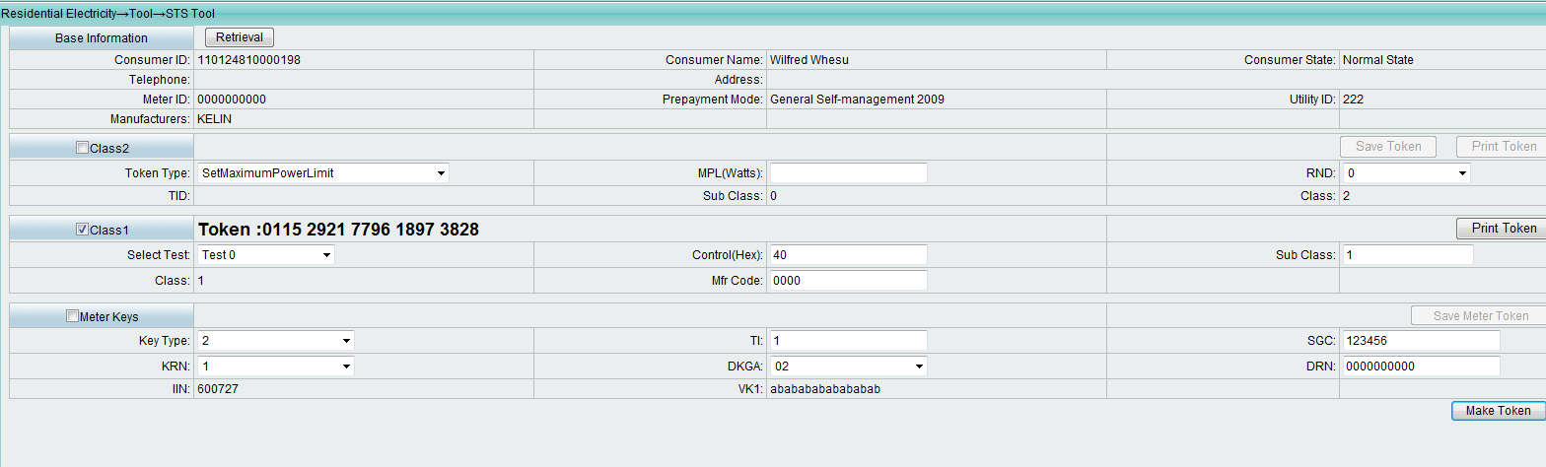

[0032] - STS531-1-0-02: CTSA11 Test Step: 8

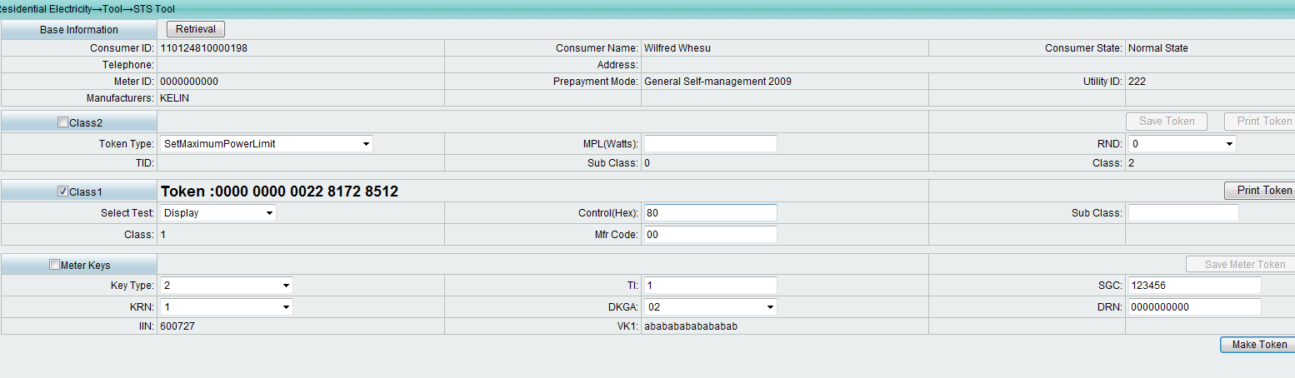

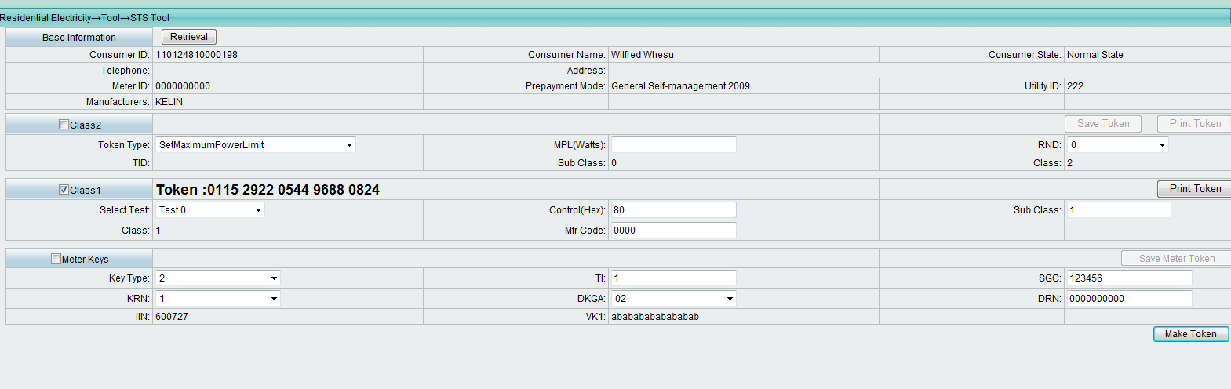

[0033] - STS531-1-0-02: CTSA11 Test Step: 9

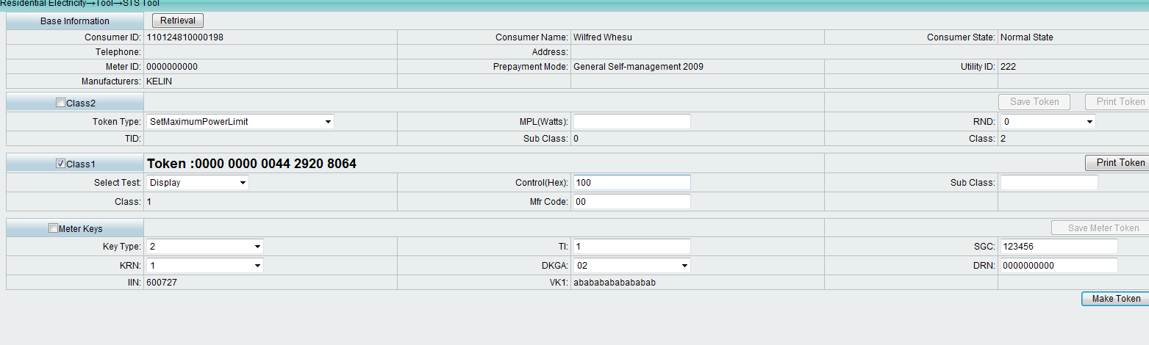

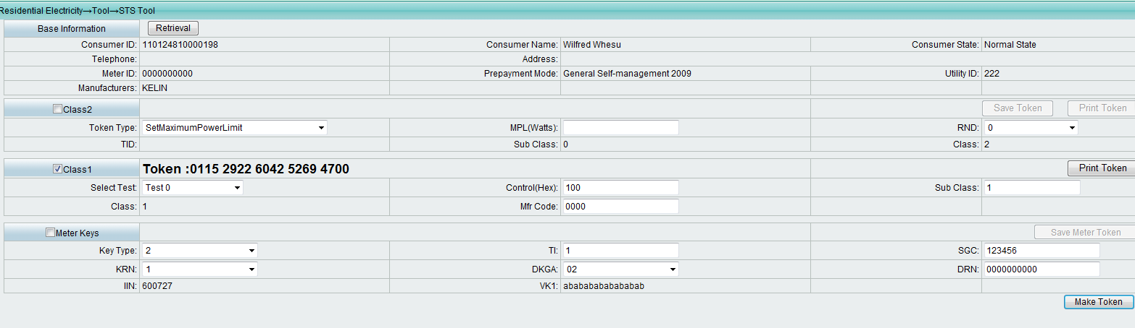

[0034] - STS531-1-0-02: CTSA11 Test Step: 10

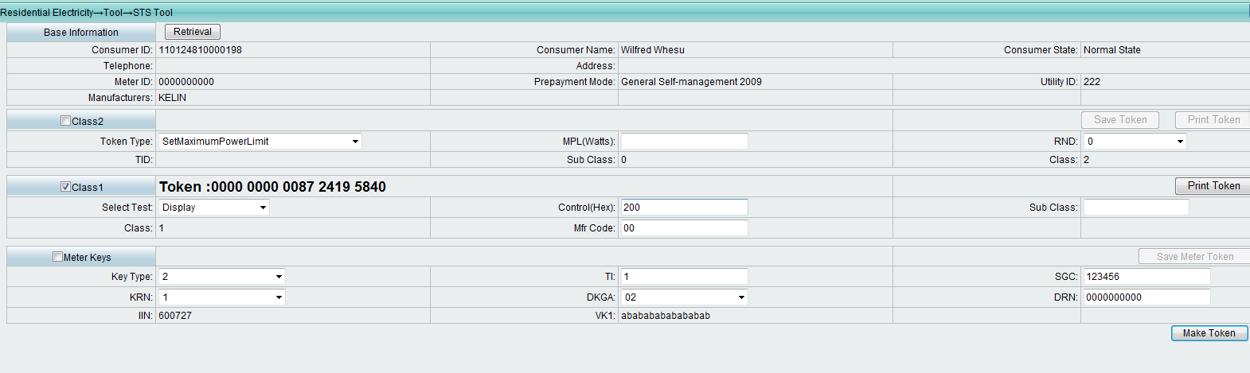

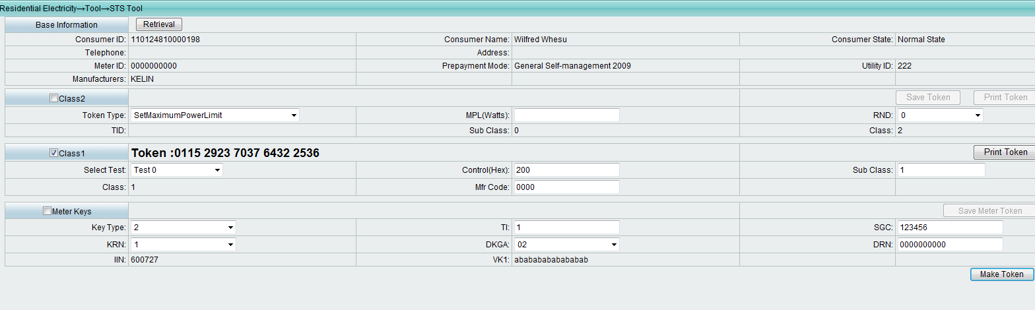

[0035] - STS531-1-0-02: CTSA11 Test Step: 11

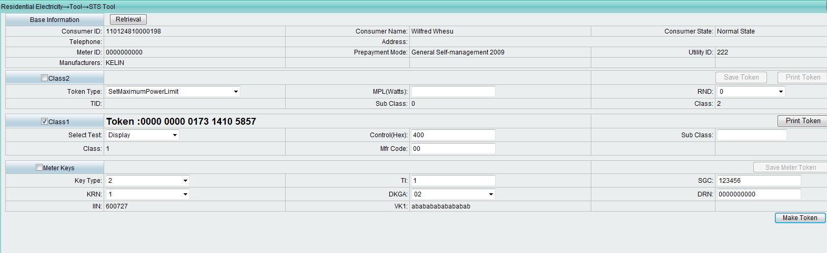

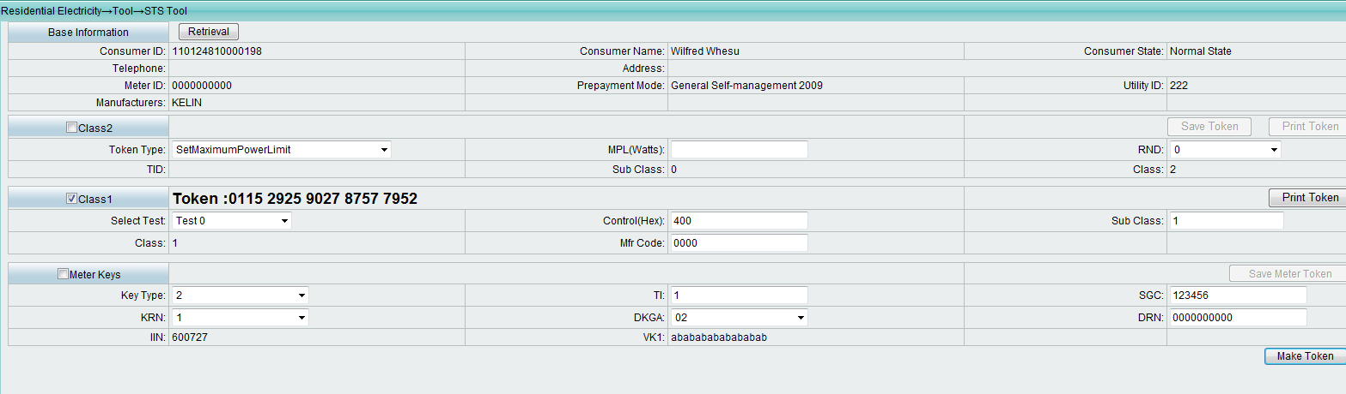

[0036] - STS531-1-0-02: CTSA12 Test Step: 1

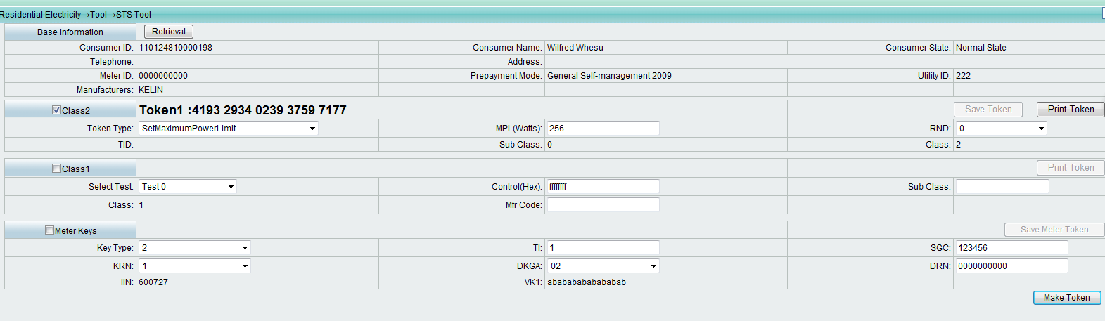

[0037] - STS531-1-0-02: CTSA12 Test Step: 2

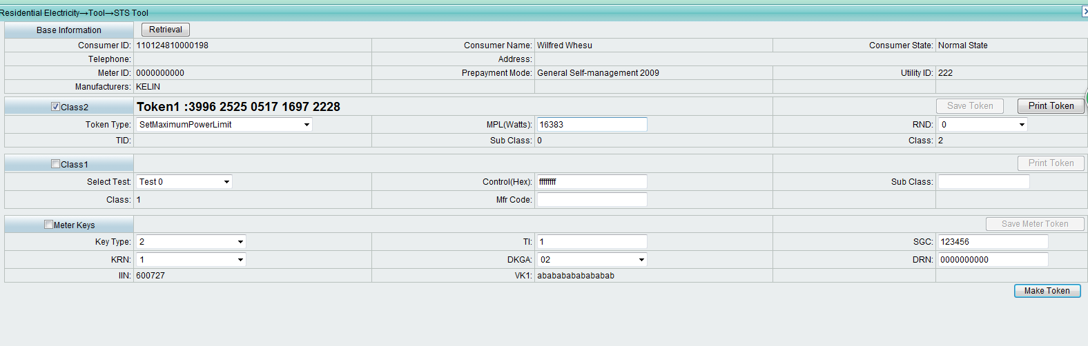

[0038] - STS531-1-0-02: CTSA12 Test Step: 3

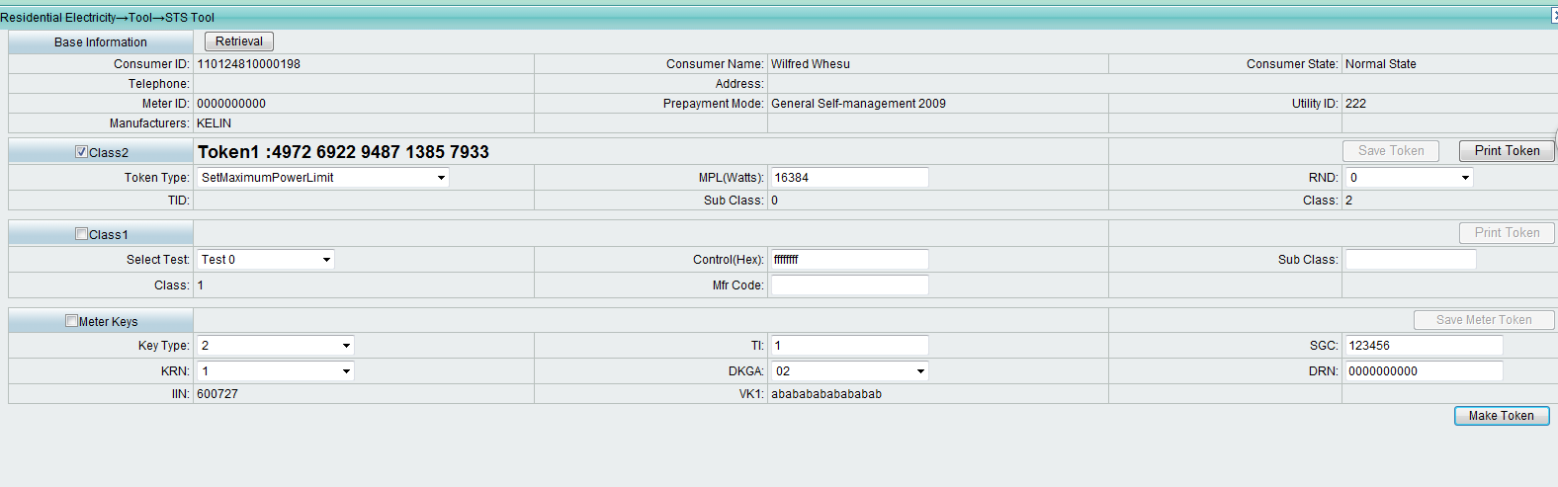

[0039] - STS531-1-0-02: CTSA12 Test Step: 4

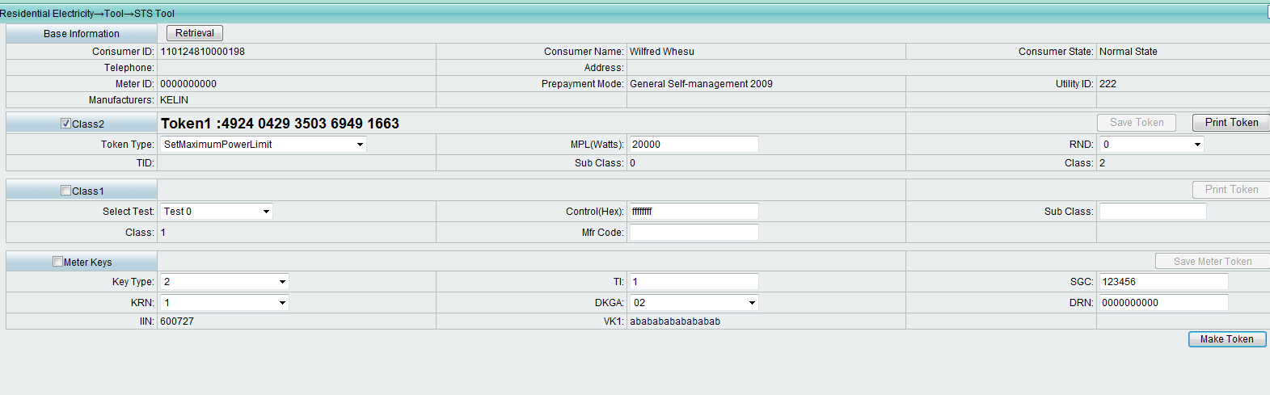

[0040] - STS531-1-0-02: CTSA12 Test Step: 5

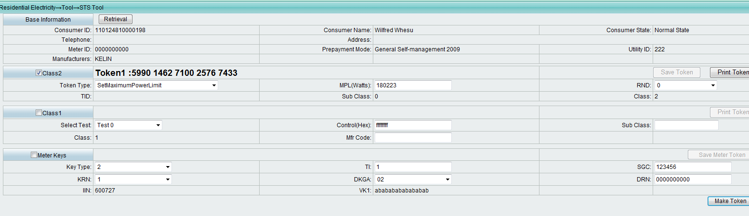

[0041] - STS531-1-0-02: CTSA12 Test Step: 6

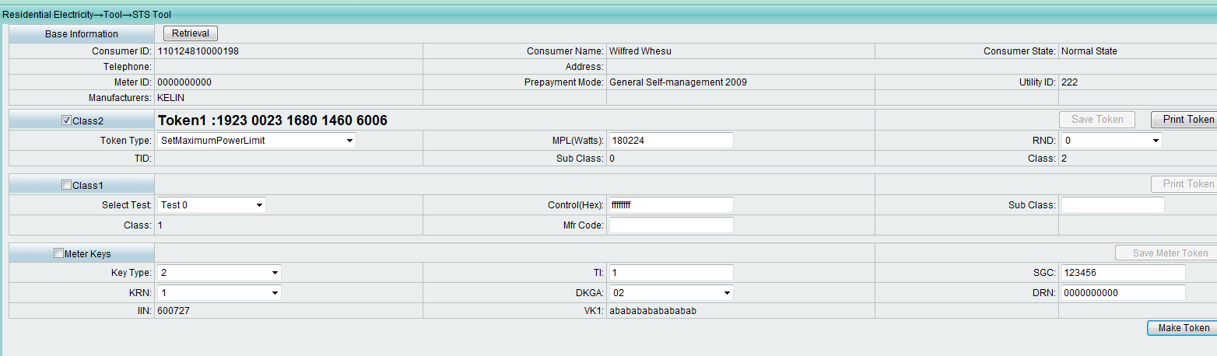

[0042] - STS531-1-0-02: CTSA12 Test Step: 7

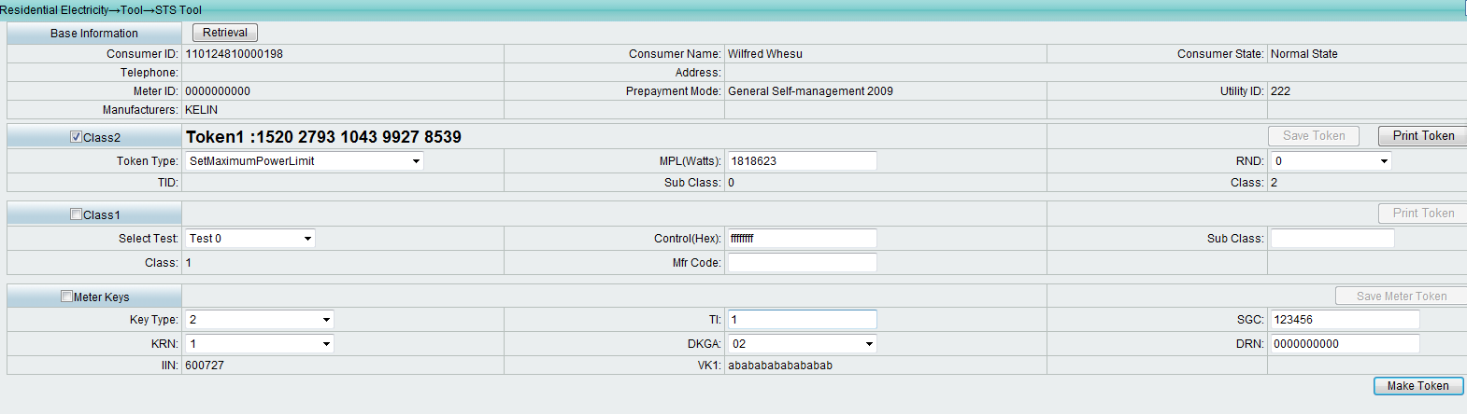

[0043] - STS531-1-0-02: CTSA12 Test Step: 8

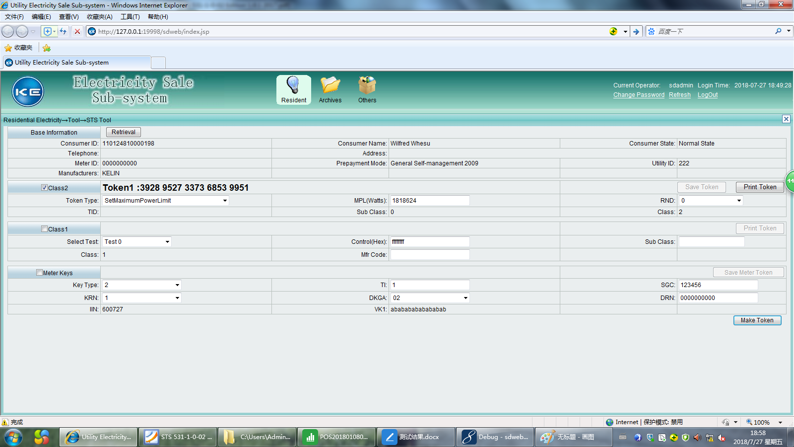

[0044] - STS531-1-0-02: CTSA12 Test Step: 9

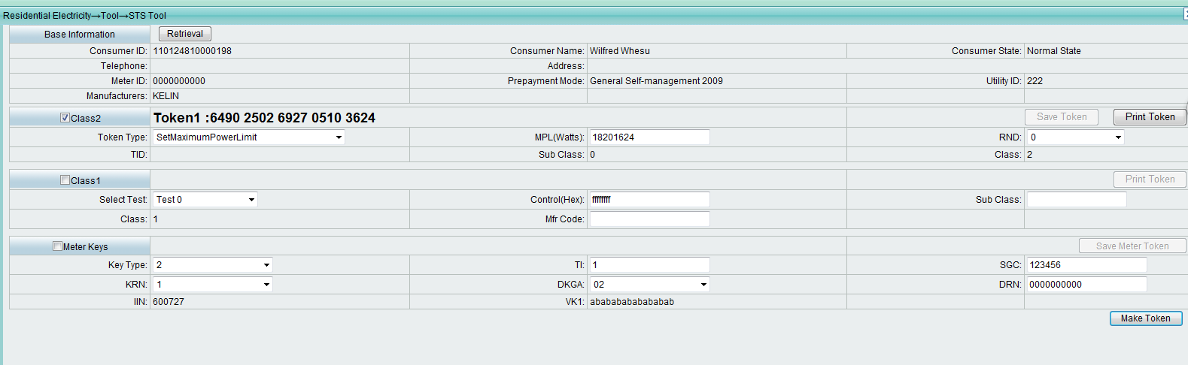

[0045] - STS531-1-0-02: CTSA13 Test Step: 1

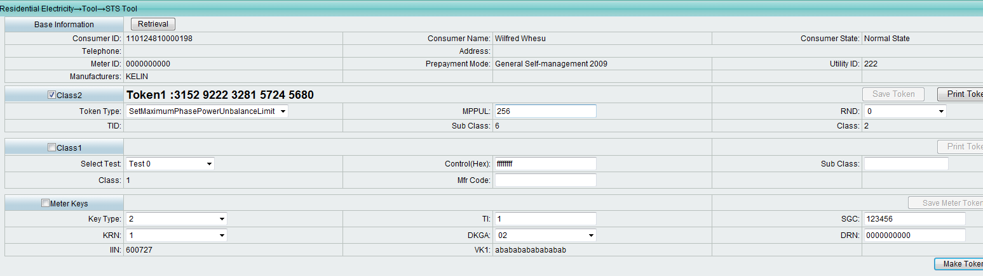

[0046] - STS531-1-0-02: CTSA13 Test Step: 2

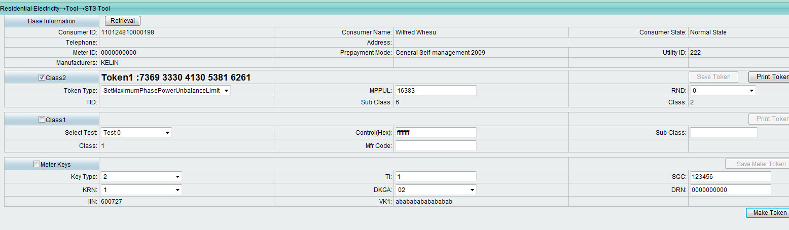

[0047] - STS531-1-0-02: CTSA13 Test Step: 3

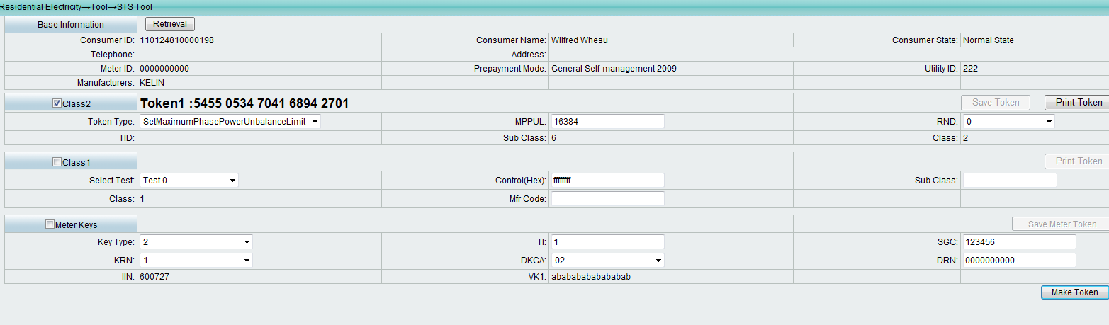

[0048] - STS531-1-0-02: CTSA13 Test Step: 4

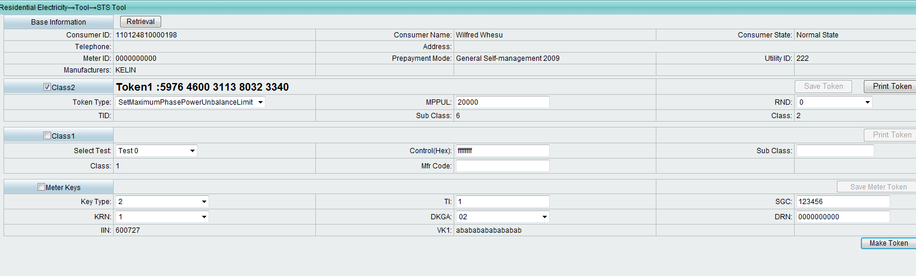

[0049] - STS531-1-0-02: CTSA13 Test Step: 5

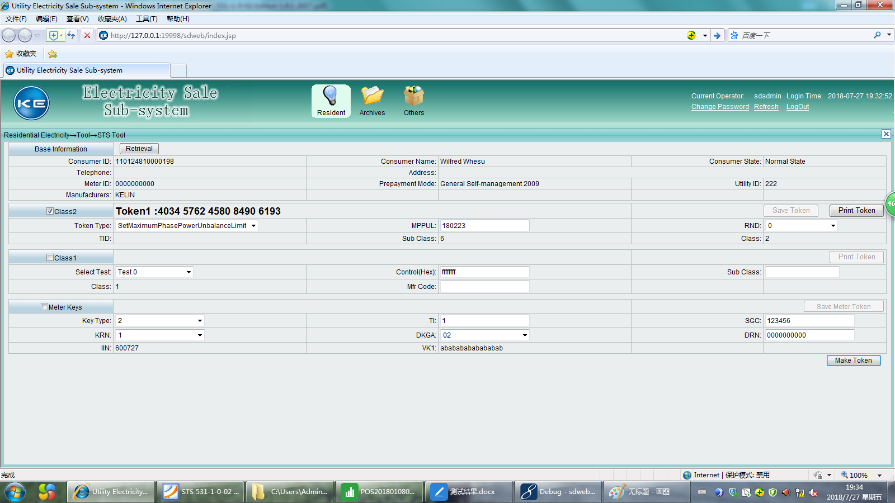

[0050] - STS531-1-0-02: CTSA13 Test Step: 6

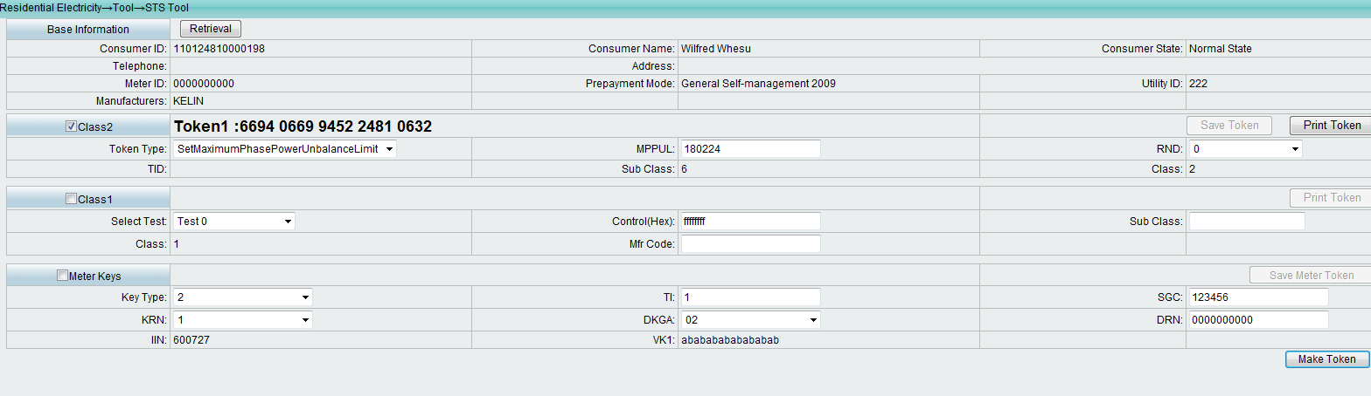

[0051] - STS531-1-0-02: CTSA13 Test Step: 7

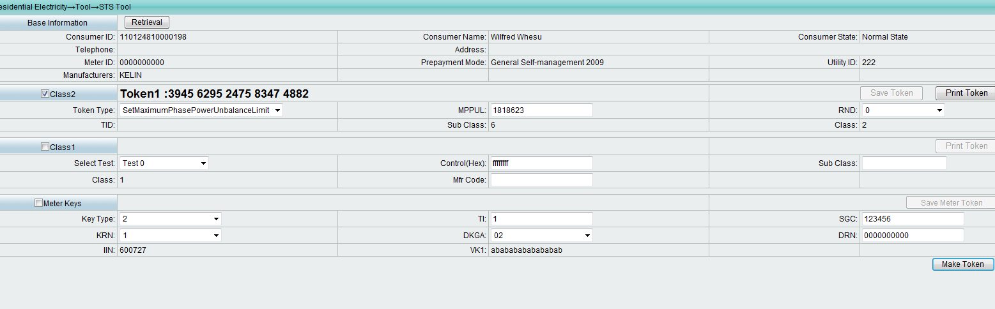

[0052] - STS531-1-0-02: CTSA13 Test Step: 8

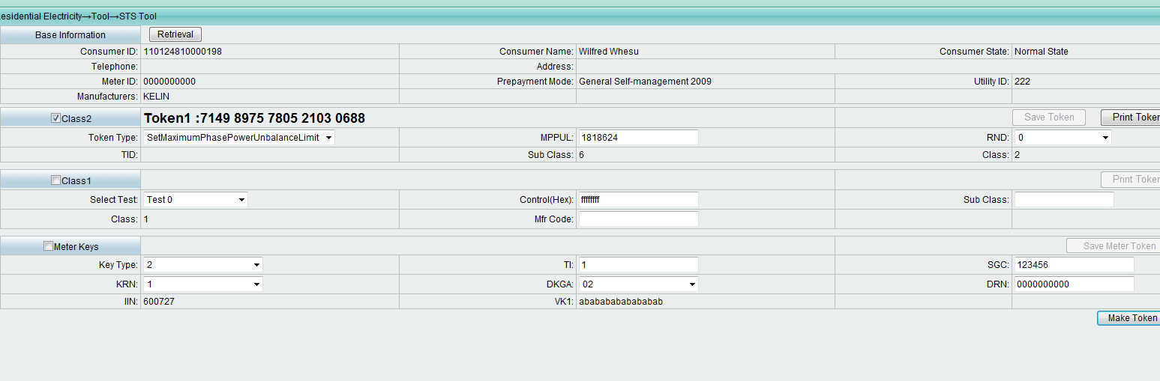

[0053] - STS531-1-0-02: CTSA13 Test Step: 9

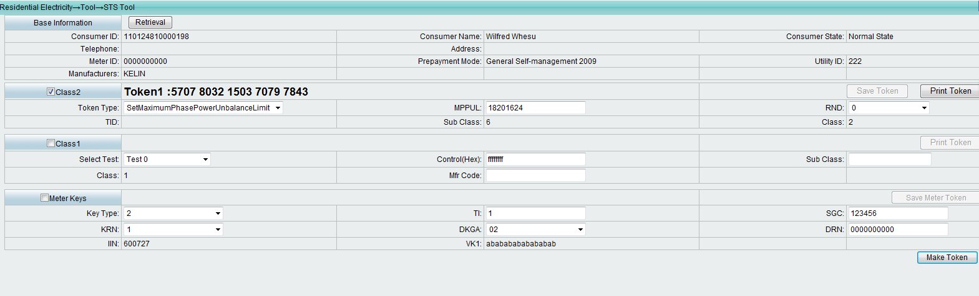

[0054] - STS531-1-0-02: CTSA14 Test Step: 1

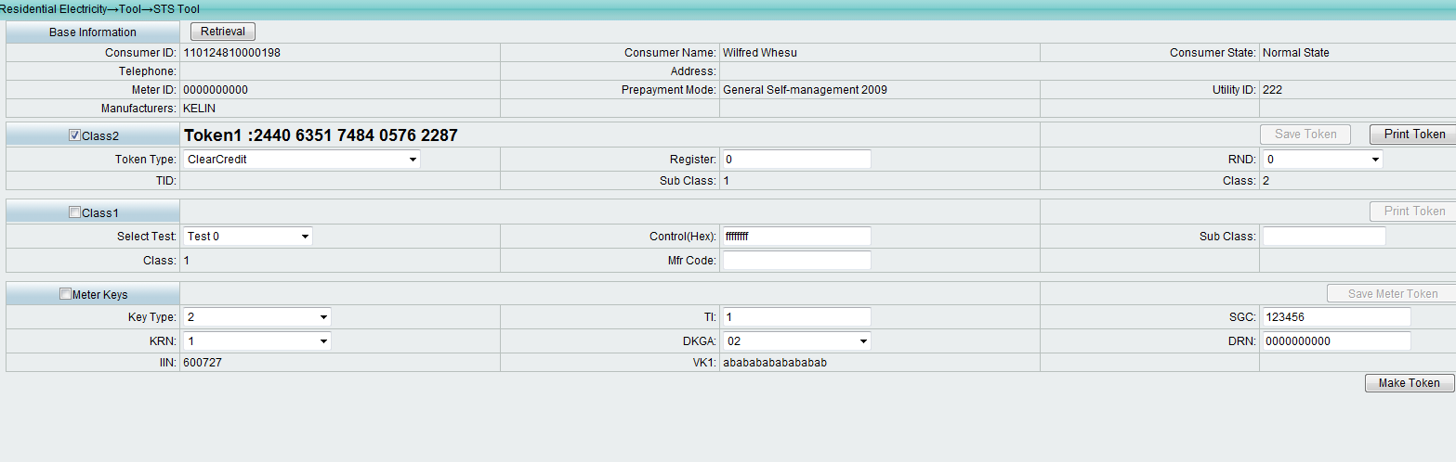

[0055] - STS531-1-0-02: CTSA14 Test Step: 2

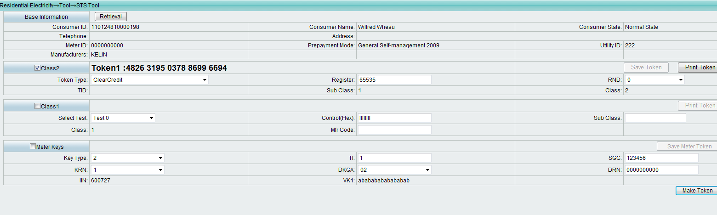

CTSA16 – KeyExpiryNumber

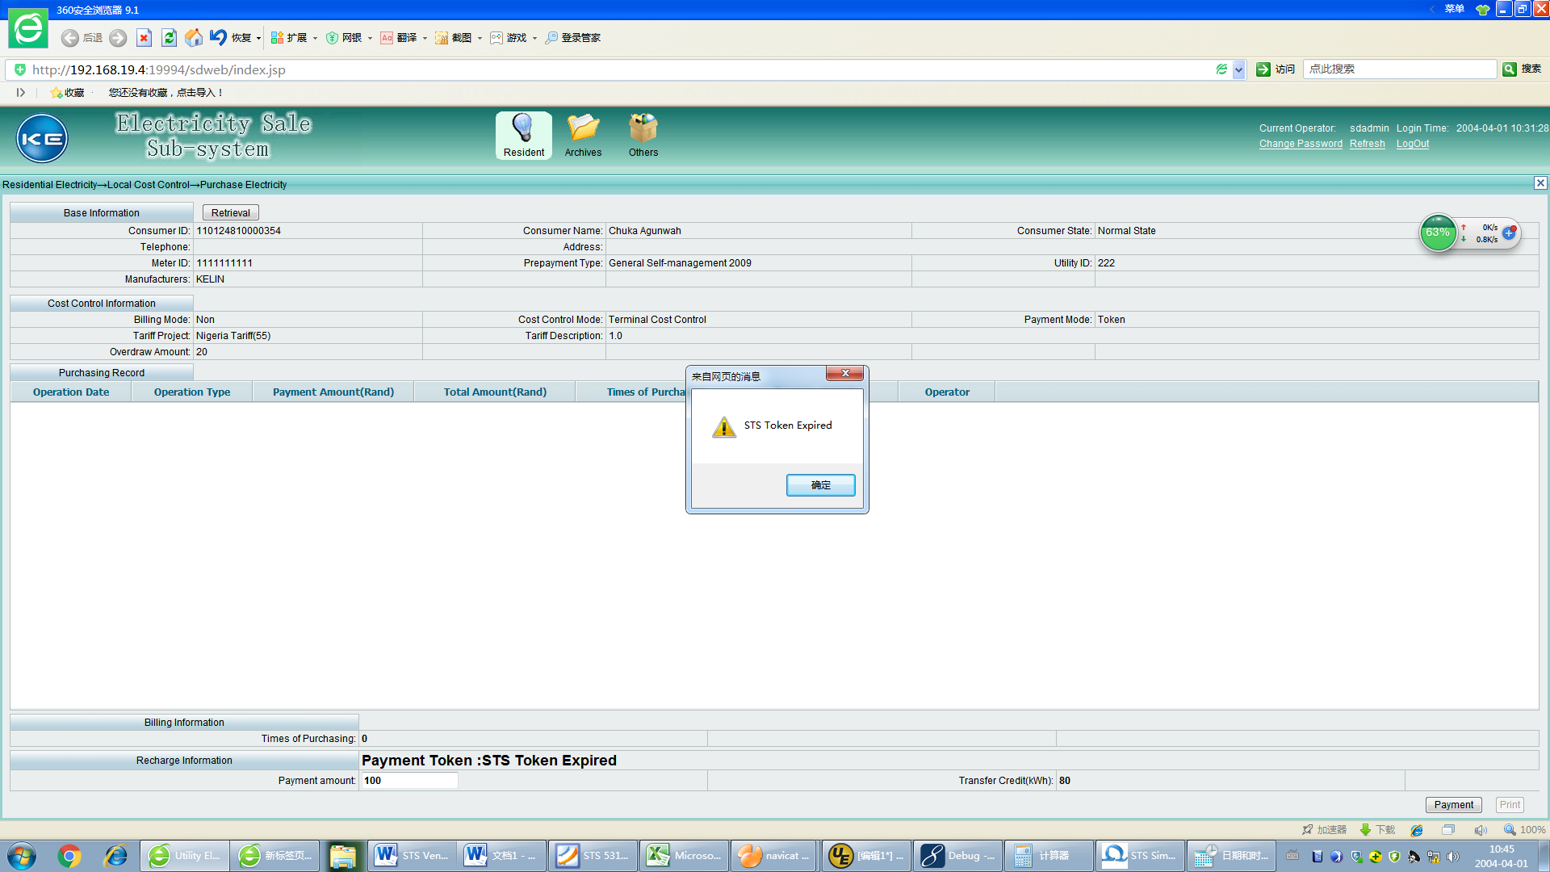

CSTA17 – DRN Check Digit 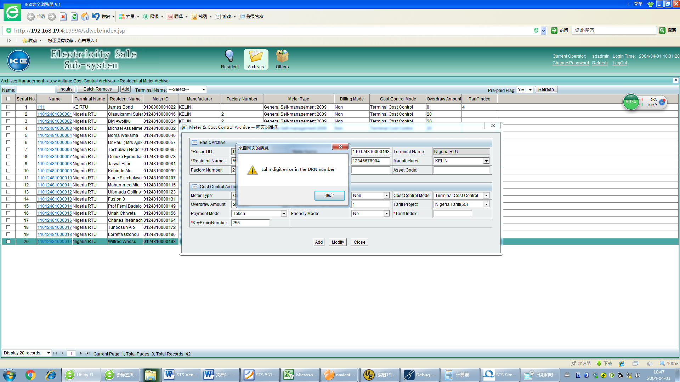

[0061] - STS531-1-0-02: CTSA19 Test Step: 1

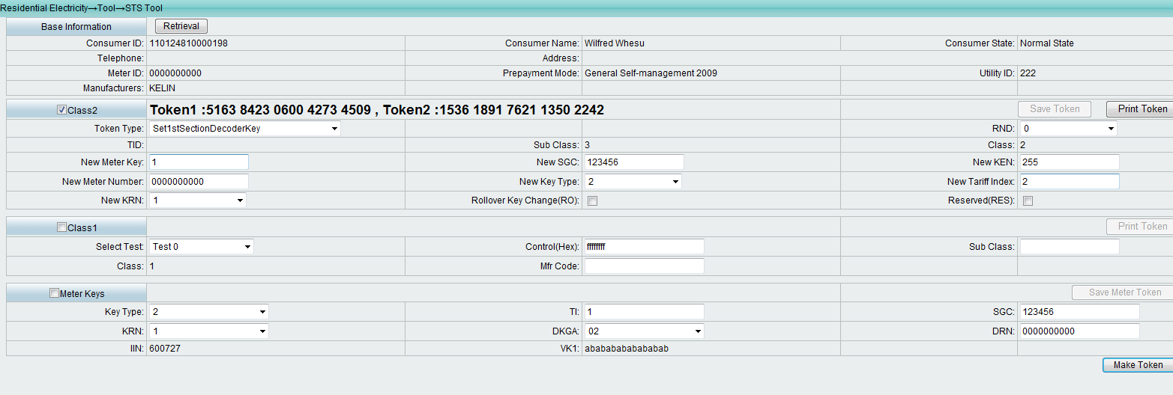

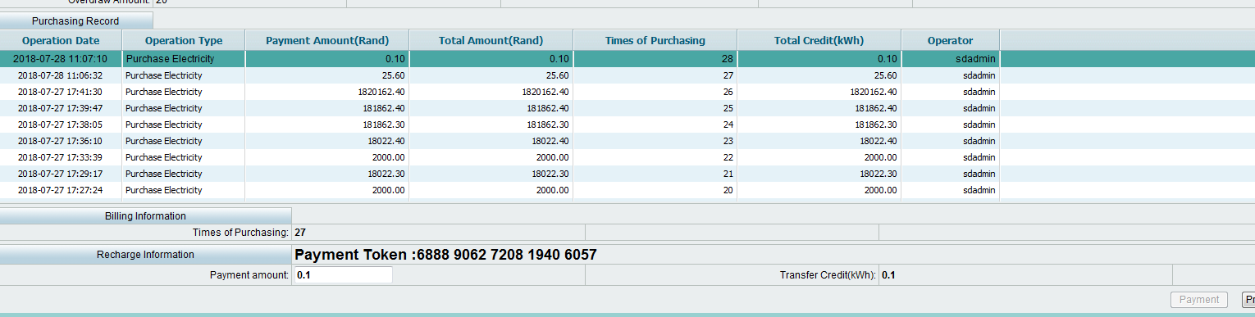

[0062] - STS531-1-0-02: CTSA19 Test Step: 2

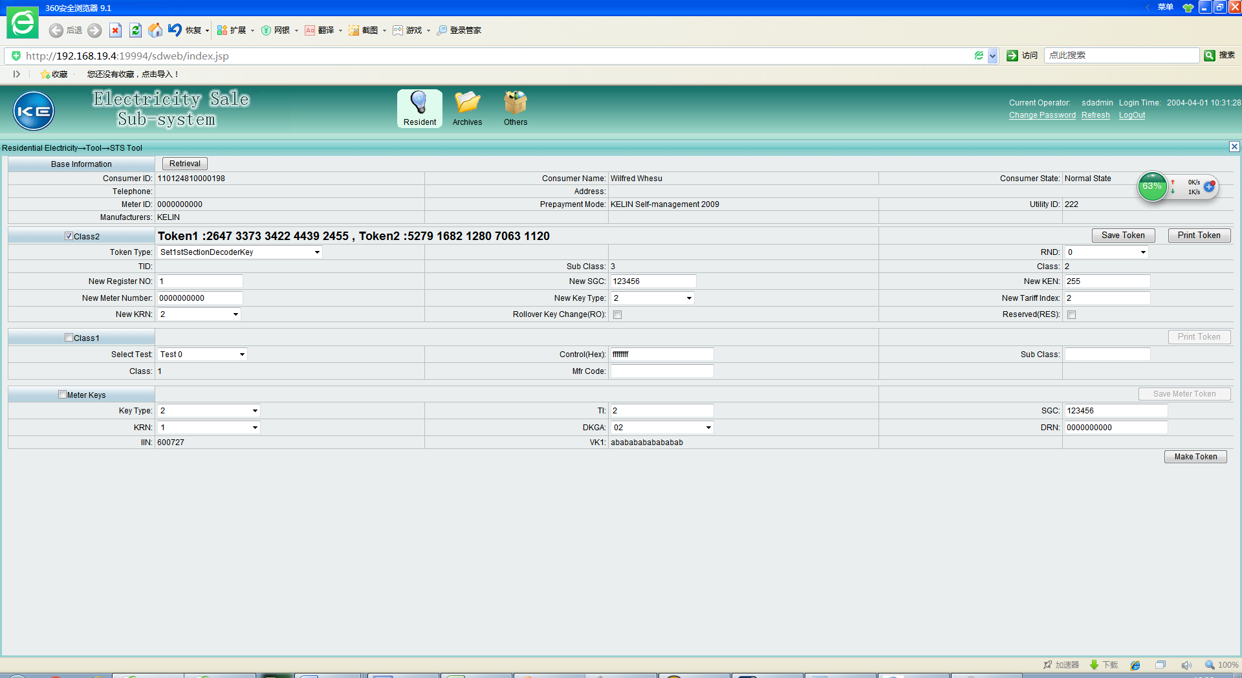

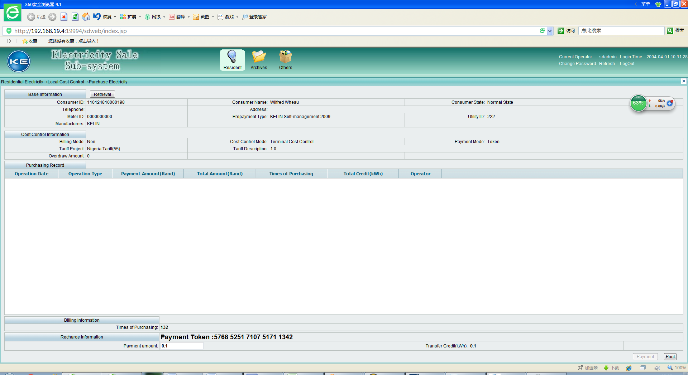

[0063] - STS531-1-0-02: CTSA19 Test Step: 3

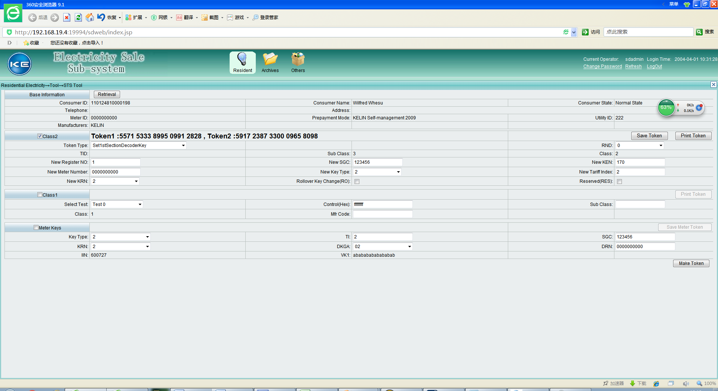

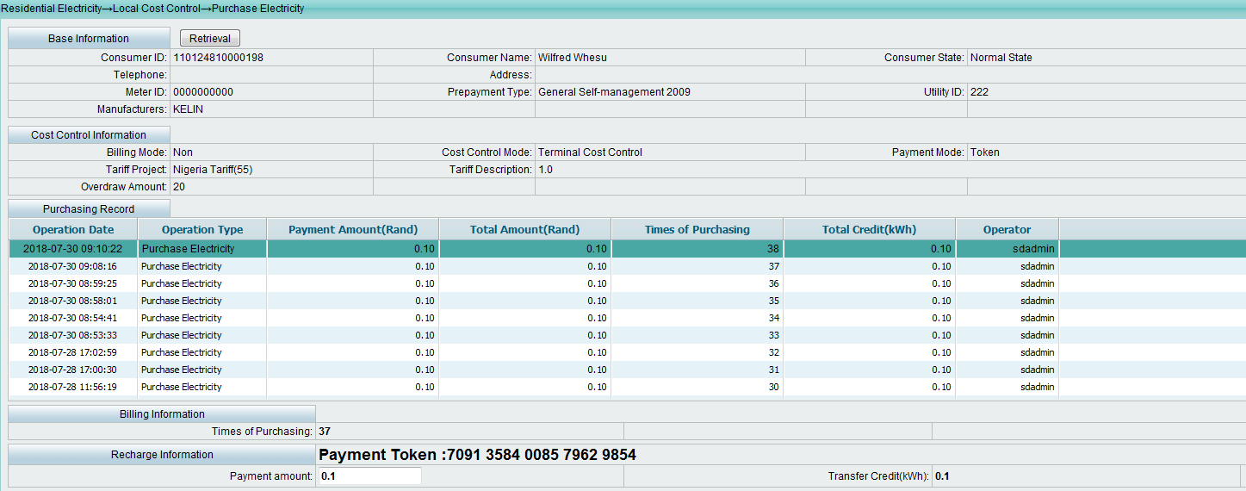

[0064] - STS531-1-0-02: CTSA19 Test Step: 4

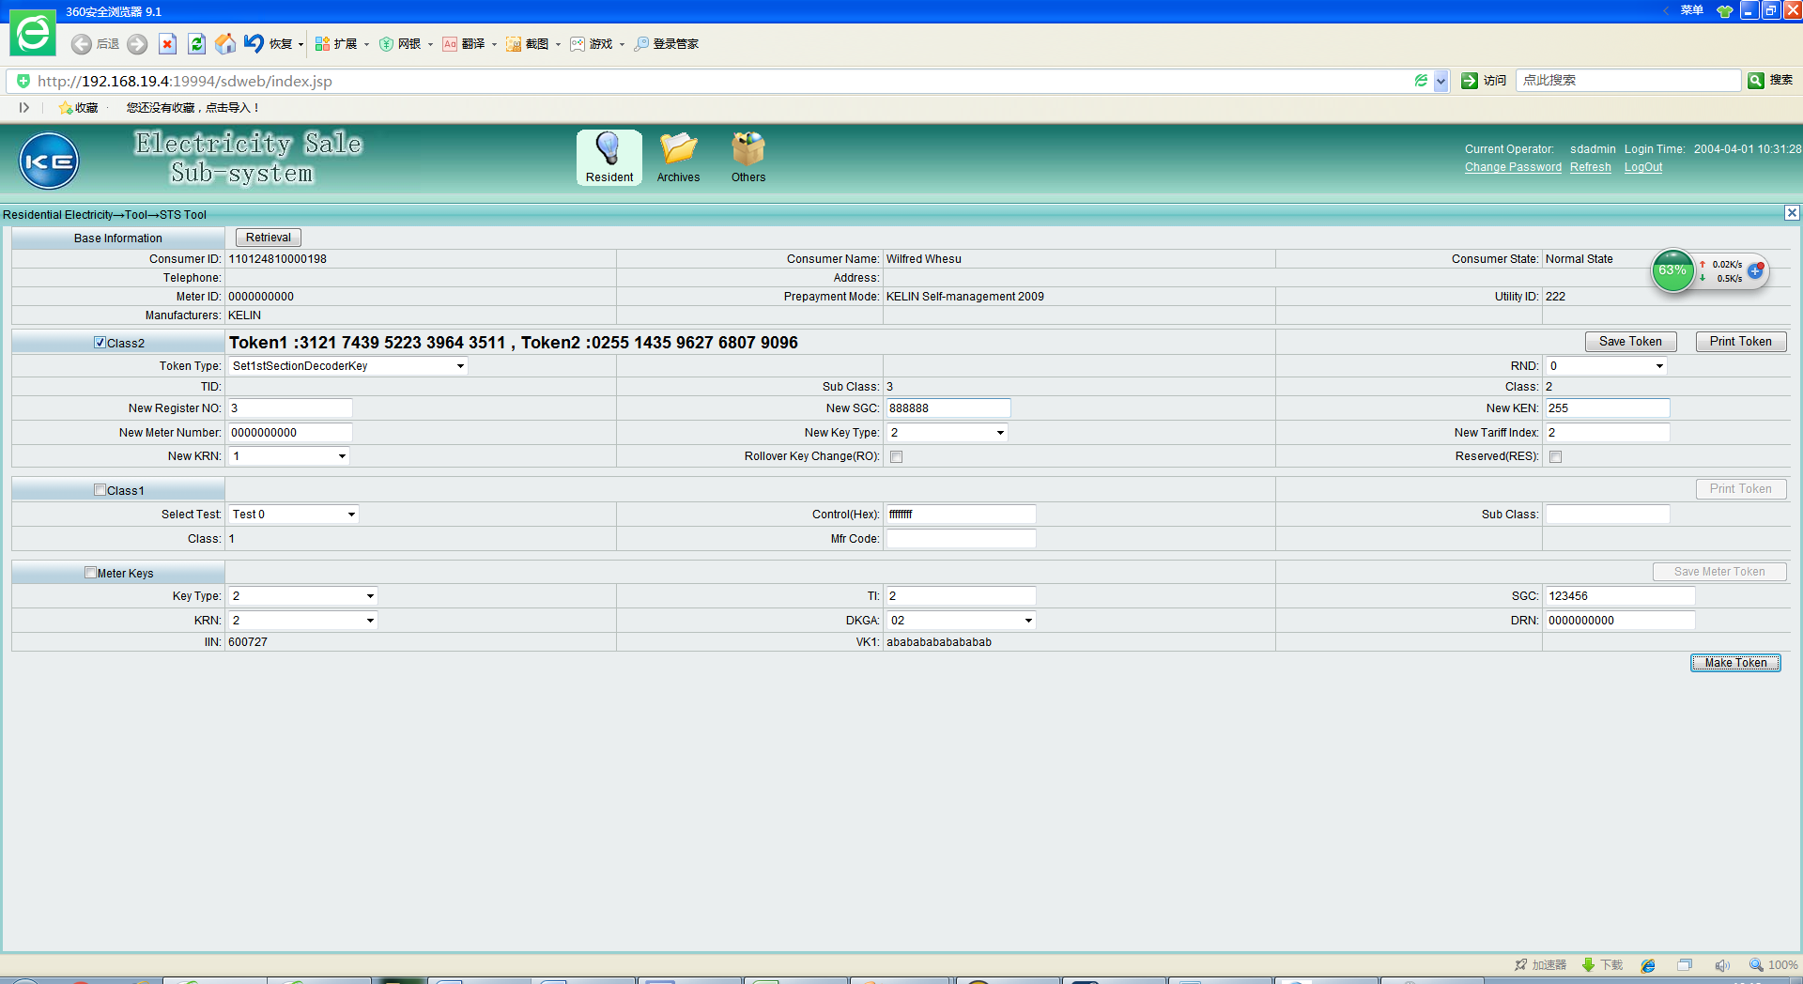

系统里需要修改ORGSTS中的KMF值，对应到寄存器3，SGC改成888888

Web界面或者手工改下库!在org_stspara里

9520LK01MST872BD4975105DD1993D18299000000000020180226144901201801250200001255123456KELIN

9520LK03MST872BD4975105DD1993D18299000000000020180226144901201801250200001255888888KELIN

注意：检测要求的是修改KEN/KRN/SGC/TI/KT等参数后，能自动标记为keychange状态，当用户下次买电时自动产生keychange密钥（调用SM?TK指令）及售电密钥（强调在售电操作中一起产生），不通过销户开户操作。

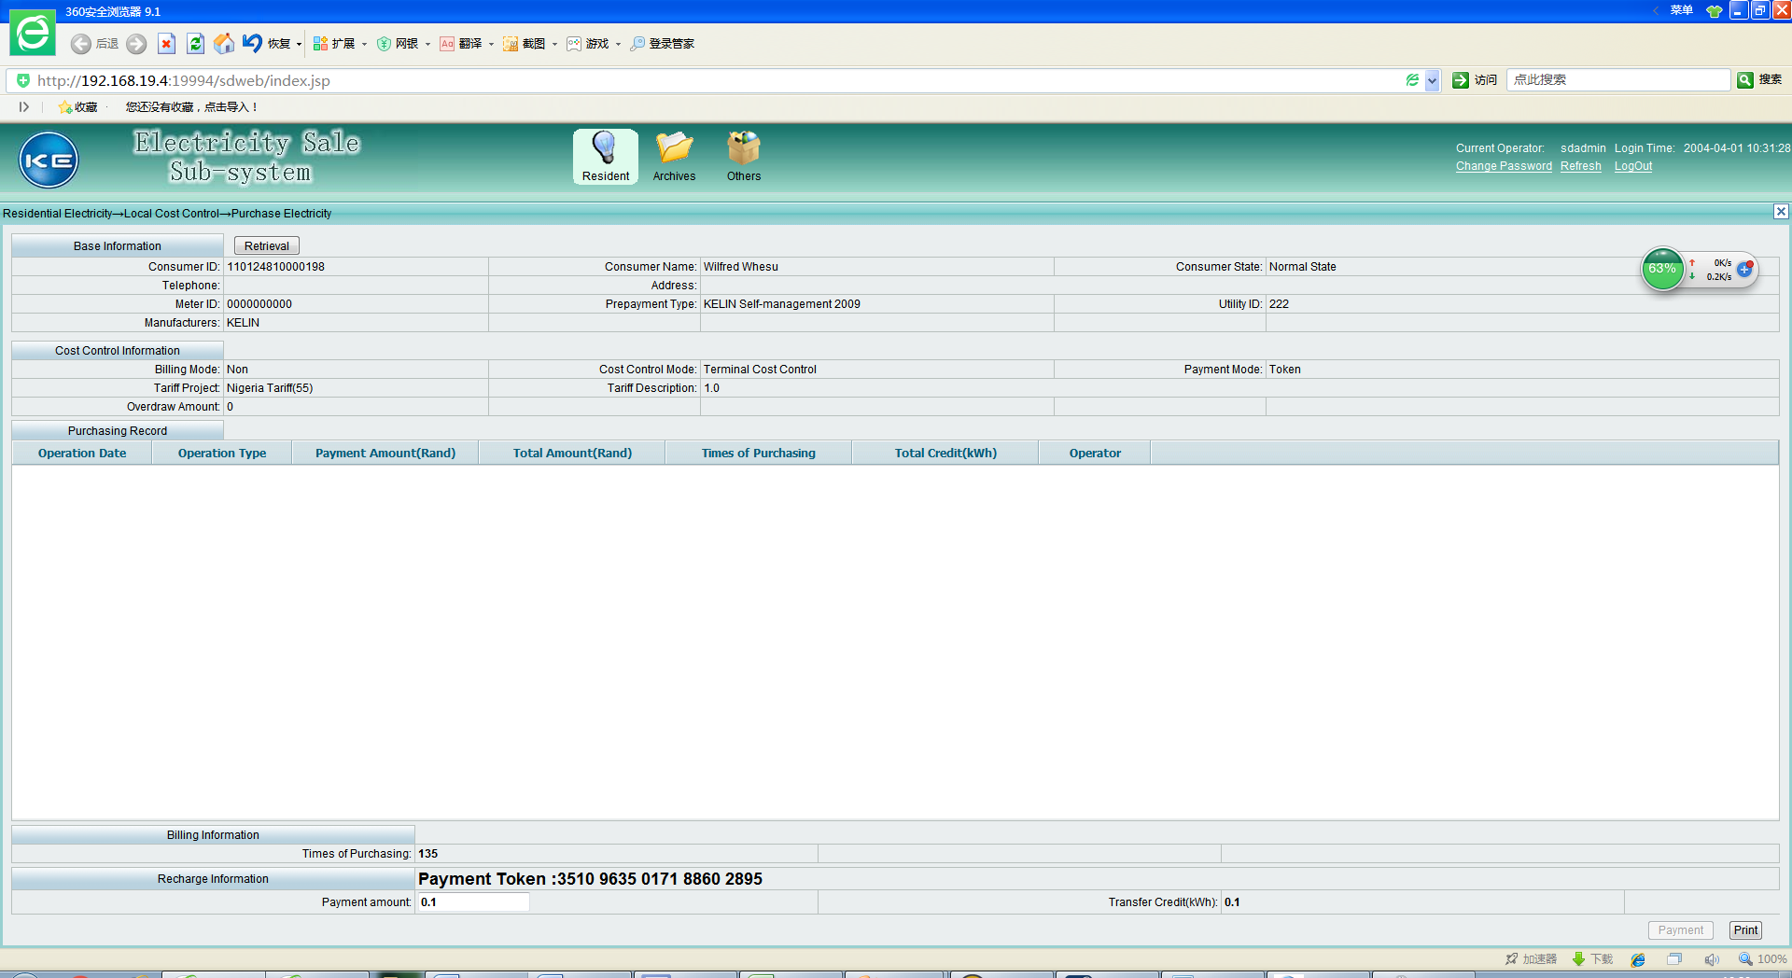

## Question1: SM?TS balance

使用VSM软件售电后，使用SM?TS命令回读，balance中的钱没有减少，与下图示例中balance扣减缴费金额后余额为0情况不一致。为什么？

After the electricity sale used by VSM software and the SM?TS command is used to read back, the money in the balance is not reduced. This is inconsistent with the situation in which balance is 0 as shown below. Why?

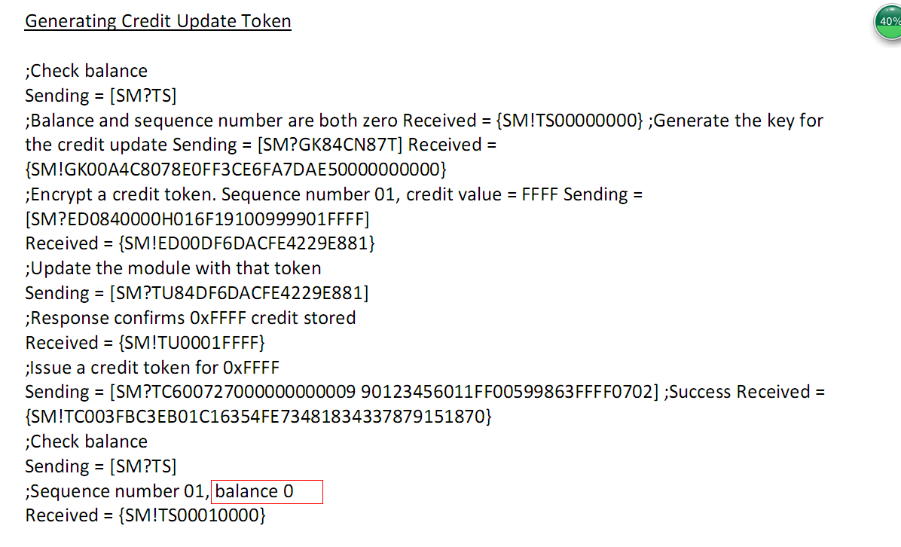

## Question2: Credit Update Block

Credit update block中, C (Credit update function code)的含义及区别，适用于哪种售电类型？目前售电中取值是1。

What is the meaning and distinction of C (Credit update function code) in Credit update block and which vending type is suitable for? The current value in the vending is 1.

S(Credit Updates Sequence Number digit)中，两个S怎么用，表示十进制01-99递增吗？

What does the two “S” in S (Credit Updates Sequence Number digit) stand for? Does it mean 01-99 decimal progressive increase?

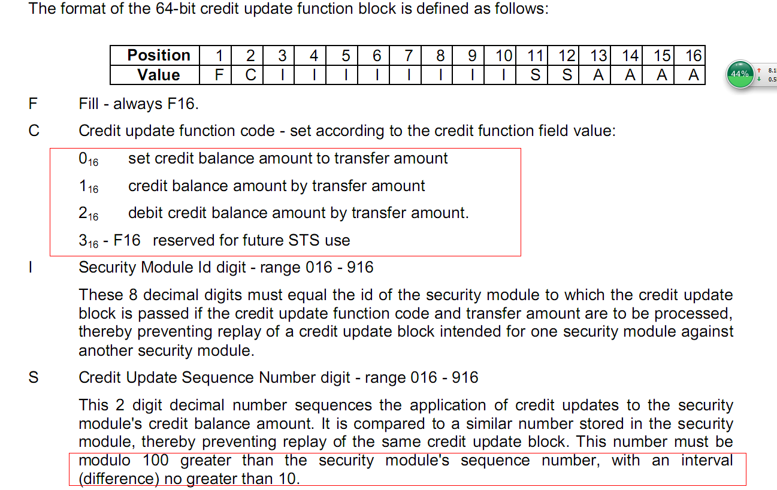

对KEN(KeyExpiredNumber)的理解，KEN表示了0-255个分钟时间段，每个时间段表示65535分钟，从sts基准时间开始，计算TID，当TID超过(KEN*65535)的值以后，则认为电表的有效使用时间过期，提示过期，不再产生token